

**Measuring the Effectiveness of a Gamified Smartphone App in Encouraging Healthy Behaviour Amongst Students**

**COMSM3201 – Computer Science MSc Project**

Rich Ellor

re16621

**Supervisor**: Peter Flach

MSc Computer Science Conversion

MS50

University of Bristol

**Due** **date**: 15th September 2017

**Confirmation**

I confirm that this report is my own work and that all sources are fully referenced and acknowledged throughout.

**Word Count**: 18,337 words

**Page Count**: 72 (content); 98 (total)

**Signature**:

**Submission Date**: 15.09.2017

**Acknowledgements**

I would like to take this opportunity to express my gratitude to my supervisor, Professor Peter Flach, for his constant support and encouragement during the development of this project. His guidance and expertise have been instrumental throughout all stages of the process.

I would also like to thank those who take part in the pilot study and subsequent user study. Without your input, this project would not have been a success.

**EXECUTIVE SUMMARY**

The aim of this project is to determine the effectiveness of a gamified smartphone app in facilitating a change in behaviour amongst students. Students are known for their unhealthy lifestyles, and research suggests that the habits they inherit at university are carried forward into later life. A literature review found self-monitoring, feedback, and goal-setting to be the most prevalent gamification techniques used in existing apps and prior studies. Therefore, a dieting app has been developed – utilising these gamification techniques in order to improve students’ unhealthy behaviour, with an emphasis on reducing sugar consumption. Notably, this project is 70% Type I and 30% Type III.

The app includes a local, SQLite database that stores user information, food items, and a diary of food consumed by the user. It also employs an online food database API (Nutritionix), which contains thousands of food items and their nutritional contents; a previously developed, open-source free-throw game to encourage continued use of the app; and an online MySQL database to store user data. The latter involved creating a static IP address and utilising a dynamic domain name.

The app was evaluated by conducting user studies on a sample of 10 students; students were asked to identify which of the three gamification techniques had the biggest impact on their *claimed* behavioural change. Their sugar consumption was also monitored throughout the study and comparisons made between half the cohort who were advised to set goals and those who were advised not to. Results found that feedback was the most significant of the three techniques, and that those who set goals had a more significant reduction in their sugar levels over the course of a week compared to those who didn’t.

As an extension task, a machine learning linear regression equation was developed based on the results of the user studies – the training data was made up of days logged by each user, with the percentage contribution to daily intake for the nutritional contents of the food acting as the features, and the change in weight as the predictor variable. The equation was evaluated by measuring the researcher’s own weight over a 2-week period. Results concluded that the equation was more accurate than an existing regression equation (St. Mifflin-Jeor), but that a number of factors, such as metabolism and exercise, were unknown and needed to be considered for future studies.

**Contents**

Acknowledgementsi

Executive Summaryii

Contentsiii

Abbreviationsvii

**1. Introduction1**

1.1 Background1

1.2 Research Aims2

1.3 Context2

1.3.1 App Usage2

1.3.2 Gamification3

1.4 Study Purpose4

**2. Literature Review5**

2.1 Gamification Literature5

2.1.1 Overview5

2.1.2 Applications of Gamification5

2.1.3 How Gamification Works6

2.1.4 Gamification Strategies7

2.1.5 Behaviour Change Techniques7

2.1.6 Self-Monitoring8

2.1.7 Feedback10

2.1.8 Goal-Setting10

2.1.9 Criticisms of Gamification12

2.2 Developing an App13

2.2.1 Usability13

2.2.2 Wireframes14

**3. Methodology & Design15**

3.1 Development of Objectives15

3.2 Tasks for Project16

3.3 Deliverables16

3.4 Developing the App17

3.4.1 Wireframes17

3.4.2 Android Studio17

3.4.3 Android Activity Lifecycle18

3.4.4 Database18

3.4.5 Free-Throw Game18

3.4.6 User Studies19

3.5 Extension Task – Machine Learning Methodology19

3.5.1 Overview19

3.5.2 Training Data20

3.5.3 Method Outline21

**4. Development23**

4.1 User Interface23

4.1.1 Navigation Drawer24

4.1.2 HUD and Toolbar24

4.1.3 ImageSlider25

4.1.4 MPAndroidChart Library25

4.2 Nutritionix API26

4.2.1 How the API worked27

4.2.2 Returning Results to the App27

4.2.3 Limitations of the API28

4.2.4 Caching the Data29

4.3 SQLite Database30

4.3.1 Creating the Database30

4.3.2 Diary and Food Database30

4.2.1 Progress and Goals32

4.4 Online Database34

4.4.1 Creating a Server34

4.4.2 Adding Content to Server36

4.4.3 Logging in and Signing Up37

4.4.4 Hashing Passwords38

4.5 Unity Game39

4.5.1 Problems with the Game39

4.5.2 The Game inside the App40

4.6 Gamification Elements41

4.6.1 Goals41

4.6.2 Feedback43

4.6.3 Self-Monitoring45

4.7 User Acceptance Testing45

4.8 System Testing47

**5. User Studies50**

5.1 Pilot Study50

5.2 Gathering Data for User Study50

5.3 Analysis of Results from User Study52

5.3.1 Results for Objective 152

5.3.2 Results for Objective 254

5.3.3 Results for Objective 355

5.4 Qualitative Results59

5.4.1 What Respondents Liked59

5.4.2 What Respondents Felt Could be Improved59

**6. Discussion61**

6.1 Summary of Analysis and Findings61

6.2 Conclusions Drawn from Analysis62

6.3 Project Implications62

6.4 Limitations63

6.4.1 Project Limitations63

6.4.2 App Limitations64

6.5 Recommendations64

**7. Extension Task – Machine Learning66**

7.1 Method66

7.1.1 Linear Regression66

7.1.2 Gathering Data66

7.2 Implementation68

7.2.1 Finding the Regression Equation68

7.2.2 Adding the Equation to the App69

7.3 Evaluation of Machine Learning Results70

**8. Bibliography73**

**9. Appendices78**

Appendix A: Images78

Appendix B: Wireframes80

Appendix C: Database Schema82

Appendix D: Questionnaire85

Appendix E: Responses to Open-ended Questions in Questionnaire88

**Abbreviations**

**NCD** Non-Communicable Disease

**SRA** Secondary Research Aim

**BCT** Behaviour Change Technique

**SQL** Structured Query Language

**XML** Extensible Markup Language

**IDE** Integrated Development Environment   
**API** Application Programming Interface

**EFA** Exploratory Factor Analysis

**REE** Resting Energy Expenditure

**RMR** Resting Metabolic Rate

**MSE** Mean Squared Error

**SPSS** Statistical Package for the Social Sciences

**APK** Android Package Kit   
**SDK** Software Development Kit

**HUD** Heads-Up Display

**JSON** JavaScript Object Notation

**HTTP** HyperText Transfer Protocol

**UPC** Universal Product Code

**PHP** PHP: HyperText Preprocessor

**IP** Internet Protocol

**DNS** Domain Name Server

**OS** Operating System

**LQ** Lower Quartile

**UQ** Upper Quartile

**IQR** Inter-Quartile Range

**AVG** Average

**HCI** Human Computer Interaction

**RAM** Random Access Memory

**1. Introduction**

***1.1 Background***

In recent years, chronic non-communicable diseases (NCD) have become the leading cause of death and a subsequent health concern for both developed and developing countries (Ferretti, 2015). This plethora of NCDs is driven by the globalisation of unhealthy habits, such as overeating, high intake of calorific foods, and lack of exercise (*ibid.*). Within this context, poor diet has emerged as the biggest contributor to early deaths across the world (Boseley, 2015). Despite cigarettes still carrying the highest risk factor of premature death in the UK, high blood pressure and obesity closely follow (*ibid.*).

As a sub-group of the population, students are known for their unhealthy lifestyles and research suggests that 59% suffer from malnutrition (Patton-Lopez et al., 2014). It is reported that they eat fewer fruits and vegetables on average and have a high intake of high-fat, high-calorie foods (Deliens et al., 2014).

Unhealthy behaviour may lead to a series of problems related to their studies, physical health, and emotions (Patton-Lopez et al., 2014). Moreover, it is suggested that habits obtained during University are carried forward into later life (Deshpande et al., 2009). Therefore, there is a need to ensure that students’ eating habits are improved in order for them to stay healthy in the future.

Moreover, the need to cut down individuals’ sugar consumption has never been more crucial – partially due to its detrimental effects on the body (Bray & Popkin, 2014). In tandem with the link between sugar and an unhealthy diet, diabetes has become an increasingly important public health issue over the past few years (Moreira, 2013). A high sugar diet has been linked with an increased incidence of type II diabetes, and it has become more important than ever to identify which foods are contributing most to high sugar consumption (*ibid.*).

However, for the average person, it is very difficult to calculate how much sugar they are actually consuming on a daily basis, particularly as many of these sugars are ‘hidden’ in everyday items such as a pint of beer or even a tin of baked beans.

Therefore, this project aims to encourage a core target group, students, to eat healthily, with an emphasis on them cutting down on their sugar intake. As a result, a fit-for-purpose, smartphone app has been developed. By focusing on sugar intake reduction and a consequent improvement in healthy eating for students, this app will:

* Fulfil a public health need both to educate students on the risks they are taking; and
* Provide information on which are the key areas public health bodies should focus on to reduce sugar intake amongst students.

***1.2 Research Aims***

The aim of this project is to encourage healthy behaviour amongst students via a gamified, smartphone app, which will focus on reducing sugar consumption. The core objective is to measure its effectiveness in facilitating behavioural change amongst this target demographic.

***1.3 Context***

This section will outline the contextual background of the project; notably, the relevance of increased app usage worldwide, and the inclusion of gamification in a number of these apps will be identified.

***1.3.1 App Usage***

Smartphone use has increased rapidly in recent years in both developed and developing countries (Edwards et al., 2016). The number of smartphone users worldwide has surpassed 2 billion, and by 2018 one-third of the world’s population will use smartphones (*ibid.*). Mobile traffic is expected to grow at a compound annual growth rate of 53% over the next 5 years, with the total number of smartphones expected to reach approximately 50% of all global devices and connections by 2020 (Cisco, 2016). Moreover, mobile phones have shown to be effective platforms for delivering health intervention, e.g. for smoking cessation and encouraging medication adherence (Landers, 2014). Thus, it is the ideal medium in which to both educate and facilitate behavioural change in students.

There are many healthy living apps available on the App Store and Play store. Studies conducted by Park & Bae (2014) and Zhao et al. (2016) give a comprehensive review of many of these health apps, some of which focus on weight loss and exercise, and others which focus on healthy eating. Apps that aim to alter health behaviours are common (Lippevelde et al., 2016; Arnhold et al., 2014), but there is a notable lack of health apps that focus on cutting down sugar consumption (Edwards et al., 2016) – those that do merely express how much sugar is in certain foods, e.g. “That Sugar App” and “Change4Life’s Sugar Smart” app. Therefore, there is a novel opportunity to address this issue.

What this app intends to do is not only identify the amount of sugar students are consuming on a regular basis, but also aggregate the foods which are contributing most to their sugar consumption. This could prove to be an effective means of improving students’ diets, simply by identifying the ‘risk foods’ which they will need to cut out.

***1.3.2 Gamification***

In the past few years, there has been increased attention on a particular marketing phenomenon: gamification (Buckley & Doyle, 2014). Gamification has been defined in a number of ways, including: the use of characteristics commonly associated with video games in non-game contexts (Landers, 2014); the process of using ‘gaming’ elements to motivate and engage people in non-game contexts (King et al., 2013); and encompassing a broad spectrum of technology and game-like elements into commercial applications (Lister et al., 2014). These definitions have one common theme – incorporating game-like characteristics in real-life situations.

Gamification has proven to be an invaluable tool in eliciting positive changes in people’s well-being (Landers, 2014), with a lot of apps using its techniques as a means to sell goods or improve harmful behaviour. Therefore, this study will aim to incorporate gamification into its design.

In order to do so, the app will encompass a number of gamification strategies, such as points and achievements, to create a ‘competitive’ element. Furthermore, a number of behaviour change techniques (which will be identified by looking at relevant gamification literature) will be included.

In order to truly gamify the app, there needs to be some ‘fun’ element involved. Consequently, there is a ‘mini-game’ that intends to motivate the user to log on regularly, and therefore encourage them to keep track of their eating habits. It is a simple free-throw game in which the user can only play by accumulating points – done so by adding food to their diary, using the app regularly (streak points) and reaching certain targets.

***1.4 Study Purpose***

The purpose of this study is to contribute to the research of gamified design and its effectiveness in encouraging healthy behaviour. However, in order to do so, a comprehensive study of gamification literature was needed before the project could commence. This is because the gamification techniques / strategies used in the app needed to first be identified. Therefore, the following tasks were set, with the project’s objectives to be outlined later.

* Identify the most prevalent gamification techniques by reviewing relevant literature
* Review the literature on app development and usability in order to develop a truly usable application
* Thus, develop subsequent objectives for the overall project based on the information gathered in the literature review.

**2. LITERATURE REVIEW**

The appropriateness of literature is determined by those sources which focus on gamification, its techniques and applications, and app development. As stated in section 1.4, this literature review has an objective of identifying the most prevalent gamification techniques. This has also dictated the review of the relevant literature surrounding gamification.

***2.1 Gamification Literature***

This section will introduce the theory behind gamification and highlight its use in a range of academia and commercial applications. It will also identify the most prevalent techniques used globally, and critique gamification’s effectiveness as a behaviour changing tool.

***2.1.1 Overview***

As identified in section 1.3.2, gamification is the incorporation of game-like characteristics in a non-game context (Hamari et al., 2014; Landers, 2014; Lister et al., 2014; King et al., 2013). It has been a trending topic and subject to much hype in recent years as a means of supporting user engagement and enhancing positive patterns in service use (Hamari et al., 2014). Its potential to influence positive changes in health behaviour has not gone unnoticed (Landers, 2014), with many opting to use gamification in a wide range of applications.

***2.1.2 Applications of Gamification***

Park & Bae (2014) conducted a systematic review of gamification being used in commercial applications. They noted its wide adoption in the field of marketing, with over 70% of Forbes Global 2000 companies planning to use gamification for the purposes of promotion and customer retention.

A noteworthy application is the Foursquare app by Starbucks, which gave badges to people who checked in at multiple locations and offered discounts to those who became ‘mayors’ of an individual store (*ibid.*). Gamification has also been integrated into ‘Help Desk’ software. In 2012, Freshdesk integrated gamification features allowing agents to earn badges based on performance. This aimed to turn the ‘boring’ role of supporting customers into an exciting and collaborative game – and proved to be an effective way of doing so (Rao, 2012).

In addition, education and training are areas where there has been increased interest in gamification (Park & Bae, 2014). Microsoft’s Ribbon Hero 2 helps train people how to use Office effectively; Khan Academy uses it for online education; and Codecademy is a prime example of using points, badges and rewards as a way to help people learn how to code.

All of these applications, regardless of their area, have one purpose – to influence behaviour. Gamification is primarily about changing people’s habits, wants, and needs – thereby facilitating a particular behavioural outcome. This takes a number of forms such as influencing the user to spend more money, or improving a certain type of skill.

Significantly, using game elements (such as points, rankings, achievements, and rewards) in a completely non-game context, such as teaching languages or making work more fun, has proved to be an effective tool for both businesses and marketing practitioners (Park & Bae, 2014). By tapping into the user’s desires and motives, gamification aids associative learning and therefore increases their engagement with the application (Walz, 2016), thereby resulting in a change in behaviour.

***2.1.3 How Gamification Works***

Grounded in the concept of gamification is the theory of motivation. An individual’s motives are the core construct influencing their behaviour, and therefore is a key component of gamification (Griskevicious & Kenrick, 2013).

There are a number of motivation theories out there, many dating back to the early 20th century. Although many of these theories were intended to determine levels of productivity within industry, more recent motivation theory has evolved to meet the changing social, political, and economic environment (Rhee & Sigler, 2005); there is now a stronger focus on the individual’s behaviour, i.e. in theories such as self-determination theory.

Self-determination theory is an approach to human motivation and personality that uses traditional empirical methods while supporting the natural or intrinsic tendencies to behave in effective and healthy ways (Ryan & Deci, 2000). As a central tenet of the self-determination theory, intrinsic motivation describes a person’s overall satisfaction in participating in a given activity for the sake of the activity itself, whereas extrinsic motivation is contingent on reaching a goal separated from behaviour, e.g. getting a reward (Grave et al, 2013). Engaging in activities that are intrinsically motivated (or well-integrated with one’s values) and not externally controlled is central to fulfil the human being’s fundamental need for competence and autonomy (*ibid.*).

Simply put, people are motivated by personal choices. The ability to collaborate, compete and be challenged provides a level of fulfilment and self-worth. Gamification is merely a stimulus that allows people to engage in activities they may not have had prior interest in but nevertheless are now heavily involved with. It is a way of appealing to the user’s underlying motives and therefore facilitating / influencing their behaviour as a result.

***2.1.4 Gamification Strategies***

Many games provide conditional rewards (e.g. points and prizes) that risk being lost if gamers do not return frequently to play (King et al., 2013). This plays on the well-known tendencies of people to avoid losses (loss aversion) and to irrationally value things they hold over things they do not have (*ibid.*).

Furthermore, the idea that the user can achieve something, whether it be a badge, a reward, or just a step up to the next level, intrinsically motivates them towards a behavioural outcome (i.e. continued use of the game).

***2.1.5 Behaviour Change Techniques***

A behaviour change technique is an observable, replicable, and irreducible component of an intervention designed to alter or predict causal processes that regulate behaviour; that is, a technique is proposed to be an active ingredient, e.g. feedback, reinforcement, self-monitoring (Edwards et al., 2016).

As the purpose of the app is to drive behavioural change, this section will fulfil the sub-aim of identifying which gamification techniques to use in the app. Subsequently, a number of techniques will be observed from the relevant literature and therefore critiqued to determine whether they should be included.

There have been numerous studies into the concept of gamification and its ability to influence behaviour. Certain studies have focused on the techniques used to facilitate this change in behaviour, with many undertaking a comprehensive review of gamified apps and seeing which of these techniques are most prevalent (Edwards et al., 2016; Zhao et al., 2016; Middelweerd et al., 2014; Grave et al., 2013). Edwards et al. (2016), in particular, focused their review on gamified apps aimed at changing health-related behaviours.

Hamari et al. (2014) peer-reviewed empirical studies on gamification. They saw gamification as the amalgamation of three parts: the implemented motivational affordances, resulting psychological outcomes, and resulting behavioural outcomes. For their study, many motivational affordances (which are effectively ‘gamification strategies’) were tested to determine if they were in fact significant in facilitating behavioural or psychological outcomes. These affordances included: points; leader boards; achievements; badges; levels; stories/themes; goals; feedback; rewards; progress; and challenges.

Substantially, all of these affordances proved to be significant in all the papers they reviewed. Therefore, using any one of these strategies should prove to be effective in the final design of the app for this project. However, incorporating all these techniques could prove to be complex and cause subsequent issues when it comes to drawing conclusions based on the most effective techniques. As a result, the most prevalent techniques from prior studies (self-monitoring, feedback, and goal-setting) have been selected.

***2.1.6 Self-Monitoring***

Self-monitoring involves keeping a record of one’s own actions (Middelweerd et al., 2014). Many prior studies have demonstrated that self-monitoring is a key component in influencing behaviour, with some highlighting a significant association between self-monitoring and weight loss (Burke et al., 2011).

Self-monitoring is a frequently used gamification technique, with several studies noting its prevalence amongst a range of gamified smartphone apps (Edwards et al., 2016; Zhao et al., 2016; Lister et al., 2014; Middelweerd et al., 2014). Zhao et al. (2016) found that self-monitoring was the most common behaviour change technique applied in the apps they studied (12 out of 23). Additionally, Middelweerd et al. (2014) recognised 62 gamified apps using this technique as a means to influence a change in behaviour. Moreover, in the context of health-related behaviour, Edwards et al. (2016) identified 55 of the 64 health-related gamified apps they reviewed to include some form of self-monitoring, whether this was encouraging users to check their weight regularly, or expecting the user to keep track of their own eating habits.

Burke et al. (2011) focused their study on reviewing self-monitoring and its effectiveness in facilitating a change in behaviour. They highlighted that prior studies which had used therapists to monitor, control, and assist in weight-loss programs proved to be less effective in encouraging healthy behaviour in the long-term. They therefore indicated that self-monitoring techniques, adhering to specific criteria, proved more conclusive in improving the respondents’ unhealthy habits.

Noticeably, many gamified apps on the App Store or Google Play incorporate self-monitoring, including Noom’s Weight Loss Coach, Jillian Michael’s Slim Down, and MyFitnessPal (Chen et al., 2015). MyFitnessPal encourages the user to enter their reported weight, the foods they eat, and the exercise they do on a daily basis. This constant level of self-monitoring is intended to encourage the user to not only keep track of their unhealthy habits, but also to improve their health behaviour. Likewise, other health-related apps often expect a high-level of self-monitoring. It is often expected of the user to log their weight and update their food diaries regularly (Burke et al., 2011). This highlights how existing apps are driving users to keep track of their own progress in order to facilitate a change in behaviour.

Thus, self-monitoring is likely to be an effective means of encouraging a change in behaviour and, in line with this project’s aims, will therefore be a suitable technique that this app can utilise.

***2.1.7 Feedback***

Feedback shifts the focus towards the positive and negative consequences of behaviour and action, rather than focussing on the physiological and physical constructs prior to behaviour (Wilson et al., 2015). Numerous studies have identified feedback to be a significant behavioural change technique (BCT), with many aforementioned authors noting its prevalence in gamified applications (Edwards et al., 2016; Zhao et al., 2016; Middelweerd et al., 2014).

In Edwards et al.’s (2016) study, 94% of the apps reviewed included some form of feedback (60 out of 62), with Middelweerd et al. (2014) identifying 64 gamified apps using feedback to facilitate behavioural change. Moreover, Zhao et al. (2016) found 8 of its 23 studied apps utilised this technique, but with a particular emphasis on ‘personalised’ feedback. The idea of logging statistics and providing generic information was not regarded as ‘relevant’ feedback by these researchers, who believed feedback should be tailored to a person’s characteristics in order to be truly effective. Likewise, Middelweerd et al. (2014) only included apps with personalised feedback in their study.

In Zhao et al.’s (2016) study, patients were given a diabetes management app where they could continuously monitor their glucose levels (glycaemia). The usage of the app was high amongst participants, who showed significantly improved control over their condition. This was attributed to a number of important features of the study, such as a user-friendly design, usefulness of information, and weekly personalised text-message feedback from health care professionals. This continued feedback proved to be an important factor in the app’s adoption and the participants’ change in behaviour. Considerably, the elements of gamification in an app and immediate feedback help to keep players motivated and involved in self-management (Edwards et al., 2016). Therefore, this highlights the effectiveness of immediate, tailored feedback in facilitating a change in health behaviour. Consequently, this technique will be included in this author’s smartphone app.

***2.1.8 Goal-Setting***

Finally, another significant behaviour change technique noted by prior studies is goal-setting. Goals have a pervasive influence on behaviour and an individual’s performance (Locke & Latham, 2002 ***in***Lunenburg, 2011). A goal can be defined as an object of one’s ambition or efforts (Lunenburg, 2011) and is a particularly relevant construct when it comes to improving one’s health.

Prior studies have stressed the significance of goal-setting as a behaviour change technique (Edwards et al., 2016; Zhao et al., 2016; Howlett et al., 2015; Middelweerd et al., 2014; Cecchini et al., 2010). Notably, 52 of the 64 apps reviewed by Edwards et al. (2016) utilised an element of goal-setting; Middelweed et al. (2014) identified as many as 40 in their study.

Considerably, Zhao et al. (2016) noted that the involvement of experts providing personalised feedback according to participants’ goals a significant contributor to high levels of participant retention in their study. The concept of self-regulation coupled with a particular goal for the individuals to pursue resulted in a substantial change in behaviour (*ibid.*).

Gamification can be effective in promoting and sustaining healthy behaviours, tapping into playful and goal-driven aspects of human nature (Edwards et al., 2016). Importantly, a goal is crucial for those aiming to improve their health behaviour as it is a benchmark to success or failure; if a goal is reached, the person has succeeded. According to Lunenburg (2011), individuals who are provided with specific, difficult but attainable, goals perform better than those given easy, non-specific, or no goals at all.

The goal itself is extrinsically motivating, thereby giving the individuals an attainable target to reach. This, coupled with the intrinsic motivation of achieving that goal, fulfils the user and therefore results in a change in behaviour. In Grave et al.’s (2013) study, failure to achieve weight loss goals resulted in a relapse for obese adults. Without the intrinsic rewards of achieving their goals, the participants no longer had the drive to change their attitude. Thus, the ability to set and achieve one’s goal is a very effective determinant in facilitating behavioural change.

With all this in mind, it is vital that an element of goal-setting is included in this project’s smartphone app. As a relevant parallel, MyFitnessPal gives the user the ability to set their own goals.

However, the most effective performance seems to result when goals are specific and challenging (Lunenburg, 2011). Therefore, there is a risk that these goals do not encourage a change in behaviour and any goals will therefore have to be considered carefully when designing the app.

***2.1.9 Criticisms of Gamification***

Gamification is not without its criticisms. While gamification is widely regarded as a valuable tool for improving engagement, it has also been the centre of a great deal of controversy (Sherwani et al., 2015). For instance, most implementations miss the crucial elements of storytelling and experiences that are central to enrich the game, therefore begging the question: when is it ‘gamification’ and when is it just ‘pointsification’? – simply assigning points (*ibid.*).

It is also worth noting that whilst leaderboards, points, and badges are effective tools for communicating progress, they are the least essential element in representing the core of the game (Robertson, 2010 ***in*** Sherwani et al., 2015). Moreover, without true levels of participation by consumers, engagement may be difficult to achieve (Eisingerich et al., 2014 ***in*** Sherwani et al., 2015).

Zhao et al. (2016) highlight the significance of MyFitnessPal as an acclaimed and highly rated app amongst app reviewers. Nevertheless, in their study, they highlighted that participants showed minimal changes in behaviour, possibly due to the fact that logging their food intake took too much time.

With all this in mind, it is evident that the term gamification should not be used loosely. Thus, for this app to be truly effective, it must incorporate some ‘gaming’ element whilst also staying true to its core objective – to influence healthy behaviour.

***2.2 Developing an App***

This section will outline the importance of usability in the development of smartphone applications, as well as highlighting the significance of wireframes in app design.

***2.2.1 Usability***

Usability is a quality attribute that assesses how easy user interfaces are to use (Nielsen, 2012). On the web, usability is a necessary condition for ongoing usage. If a website is difficult to use, people leave. If the homepage fails to clearly state what a company offers and what users can do on the site, people leave (*ibid.*). This therefore highlights the importance of usability in app design. If an app is not easy to use, the user will defect to somewhere else.

Perceived ease of use refers to the degree to which the prospective user expects the target system to be free of effort (Davis et al., 1989). Developing usable websites is pivotal for e-business success since consumers touch, feel, search, and experience products (or services) through websites (Lee & Kozar, 2012). The same can apply to apps – the look and feel of them are what drive consumer engagement.

Furthermore, having a poorly designed and unusable app could be detrimental to its effectiveness. If the consumer experiences problems with the collaboration of the device, navigation, or is simply unable to read its contents, then the app’s design is flawed. All these factors frustrate the user and, as Hasan (2015) identified, can cause them to defect to another site / application. Therefore, ease of use is a key determinant of an app’s effectiveness and efforts need to be made to ensure that this app is usable.

Ahmad et al. (2014) evaluated the usability of a number of smartphone apps in their study. Several factors were tested, including usefulness, ease of use, ease of learning, satisfaction, efficiency, and help & support. Notably, screen size proved to be a physical constraint on the usability of apps, partially due to restriction on content that could be viewed on the page. Although this isn’t a constraint of the apps themselves, it is an important issue to address when considering the usability of mobile applications.

With all this in mind, usability is a key factor to consider in app development. Although, as previously identified, gamification is a useful way to facilitate a change in user behaviour through the use of engaging, game-like activities in non-game contexts, an app needs to be usable in order to be engaging. This was noted by Bhatti (2007). Therefore, not only will the app need to be gamified, it will also need to be easy to use. Consequently, wireframes were developed to showcase the layout and usability of the app.

***2.2.2 Wireframes***

A wireframe is a two-dimensional illustration of a page’s interface that specifically focuses on space allocation and prioritization of content, functionalities available, and intended behaviours (Garrett, 2010 ***in*** usability.gov, 2013).

Wireframes may be utilised by different disciplines. Developers use wireframes to get a more tangible grasp of the site’s functionality, while designers use them to push the user interface process (Brown, 2011). Moreover, UX designers and information architects use wireframes to show navigation paths between pages (*ibid.*). Developing wireframes is a collaborative effort between designers and developers since it bridges the information between architecture and visual design (Wodtke, 2009).

In summary, there are many advantages to using wireframes. For one thing, they give the developer a much clearer understanding of layout and navigational features. More importantly, they give the designer a clearer understanding of the app’s structure and how this can be adapted to make it more user-friendly.

Significantly, planning is a vital component of this project, and developing wireframes before implementation will save time and allow for further milestones to be reached at the development stage (building the app). Subsequently, wireframes are a useful tool for enhancing the user experience, and were subsequently developed before any development took place.

3. Methodology & DESIGN

***3.1 Development of Objectives***

The previous sections outlined the literature surrounding this topic. Gamification and usability are key concepts that apply to enhancing the effectiveness of this application in facilitating a change in behaviour. The app needs gamification techniques to make the content engaging and also needs to be usable to allow the user to navigate with ease.

The purpose of this study is to contribute to the research of gamification and its effectiveness in facilitating change, through the medium of a gamified, and usable, smartphone app. From the literature, 3 gamification techniques were identified which proved to be the most prevalent amongst prior studies and applications. These were self-monitoring, goal-setting, and feedback, respectively. A number of objectives have been drawn which seek to measure the effectiveness of the app and gamification techniques in facilitating change[1]:

* **SRA1**: Identify the impact of a healthy eating app on reducing sugar consumption within a sample of students over a period of 1 week prior versus 1 week after. *Measured by: quantitative data obtained from user studies detailing the level of sugar intake per student before using the app against after using the app.*
* **SRA2**: Identify the impact of goal-setting on producing behavioural change for half the cohort

*Measured by: splitting the sample in half and asking one set of respondents to set goals by the end of the week and the other set not to. This can therefore determine the effectiveness of goal-setting as a behaviour change technique by looking at the difference between the two control groups.*

* **SRA3**: Analyse which gamification technique has the greatest impact on claimed behavioural change

*Measured by: conducting a regression analysis followed by a qualitative study on the sample to determine which gamification technique proved to be the most effective in encouraging reduced sugar consumption.*

* **Machine Learning Objective**: Evaluate the effectiveness of the app’s machine learning functionality in predicting the weight gain of users over a given period

*Measured by: gauging the author’s own weight and determining the accuracy of prediction after a one week period based on a 5% confidence interval*

***3.2 Tasks for Project***

To further break down the project’s objectives, a list of tasks have been set to give an overview of what it is to be achieved by the end of the project.

* **Develop a user interface** (developed using the Android Studio IDE) which will allow the user to enter data and navigate around the app – based on wireframe designs
* **Create a back-end database** (using MySQL or SQLite) to allow data for each user to be stored and accessed accordingly
* **Add a food database API** (Nutritionix) which will allow the user to search for the relevant foods they have eaten
* **Add a “free-throw” game** (using Unity game engine) in which the user will only be able to play if they have points (which they will obtain by entering data into their food diary)
* **Implement a pilot test** of the app on a small sample of students (2-3) to allow evaluations and improvements to be made
* **Conduct user studies** on a larger sample of students (approximately 10) who will use the app for a week and then be interviewed about their experiences
* **Evaluate user studies** to allow conclusions to be drawn
* **Machine Learning functionality:** collate data from user studies and use an off-the-shelf machine learning algorithm to determine whether a person will gain weight given their current diet

***3.3 Deliverables***

In addition, a list of deliverables has been developed to showcase the ‘tangible’ aspects of the project, i.e. a core concept which can be delivered.

* A gamified, smartphone app with a user interface
* A server-side database that will store user data (both online and local to the device)
* Data obtained from user studies for evaluation
* **Optional Deliverable:** machine learning functionality

***3.4 Developing the App***

This section gives a brief outline of the app’s implementation. The app will be implemented using the Android Studio IDE (and therefore written in XML and Java). Before implementation, wireframes will be designed to represent the layout and navigation elements of the app. This will allow problems to be avoided at later stages of development. Finally, user studies will be conducted following the completion of the app to determine its effectiveness in facilitating change, and thereby to evaluate the gamification techniques incorporated.

***3.4.1 Wireframes***

As noted in section 2.2.2, wireframes are a useful tool for app design, representing the layout and navigational functionalities in a clear and concise way. For this project, the open source website, “mockingbot.com”, was used to create wireframes. All wireframes are detailed in appendix B.

There are two distinguishable elements of this app – signing in / creating an account, and the app itself. The first set of wireframes give a brief overview of the sign in / create account screens, with the second set detailing the app’s homepage, diary pages, and other content.

In addition, the images used in these wireframes were obtained from Noun project, an open source digital imaging website.

***3.4.2 Android Studio***

Developing an app from scratch can be a challenging and time-consuming task. For this project, time is limited so it is vital to ensure that it isn’t wasted on tasks that don’t necessarily contribute to the overall product. Therefore, the official IDE (Integrated Development Environment) for Android, Android Studio, will be used. Android Studio groups everything into one place, allowing time to be freed to work on more essential issues, such as usability, appearance and performance.

***3.4.3 Android Activity Lifecycle***

The Android Activity Lifecyle is an important facet of Android apps. As a user navigates through an app, the Activity instances transition through different states in their lifecycle (Android, 2017a). The Activity class provides a number of call-back methods that allow the activity to know that a state has changed – doing so makes the app more robust and performant (*ibid.*). The Lifecyle is detailed in appendix A, figure 36.

There are a number of issues that can arise if the activity lifecycle is not implemented correctly. Thus, adhering to the frameworks that Android have set out will ensure that the app avoids: crashing if the user receives a phone call or switches to another app while using the app; losing the user’s progress if they leave and return later; and crashing or losing the user’s progress when the screen rotates between landscape and portrait orientation, to name a few (Android, 2017a).

***3.4.4 Database***

Another major deliverable for this project is the server-side database that will store user data (that is, the foods which they have eaten and the points they have obtained by logging information). The database schema is highlighted in the appendices, figure 40. These tables are normalised (to third normal form) as there are no transitive functional dependencies between key and non-key attributes. (More detail on the database is highlighted in section 4.3).

***3.4.5 Free-Throw Game***

A key feature of this app is gamification. The need to incorporate gamification techniques to influence behaviour is clear but their effectiveness in encouraging users to return to the app remains uncertain. Therefore, a built-in free-throw game intends to act as way to encourage continued use and thereby improve the student’s engagement with an activity they may perceive as mundane (entering foods eaten).

The premise is rather simple. The user has the ability to play the game if they have enough points to do so. Points are obtained by logging dietary information (the main purpose of the app). The mini-game is a simple free-throw game, not dissimilar to the arcade game where players throw a basketball into a hoop and try to get as many points as they can in the desired amount of time.

Significantly, there is already an open-source free-throw game readily available online. The game itself has been developed using the Unity game engine and written in C# by Yanez (2014). The game takes a simple basketball court and overlays a hoop on top of this. A slide bar is then seen at the bottom of the screen which moves between green and red, indicating the likelihood that the ball will enter the hoop. If the user presses the screen when the bar is in the green, the likelihood the ball goes in increases. Likewise, in the red, the likelihood decreases. The image in appendix A, figure 37 shows the game design developed by Yanez (2014).

***3.4.6 User Studies***

Once the app has been fully tried and tested, a number of user studies will be conducted to evaluate its effectiveness in facilitating a change in behaviour. Notably, as this project involves user studies, some ethical considerations need to be considered. Unethical practices are those which put the user at risk. Therefore, it is wise to deliberate at what level the user studies could be considered unethical – that is, does it in any way put the user at harm or possibly require the user to divulge some personal information? Respondents are only asked questions based on their experience and required to provide their height and weight. Therefore, there are no ethical issues with this user study.

***3.5 Extension Task – Machine Learning Methodology***

This subsection outlines the machine learning objective of the project. It gives a brief overview of how the app intends to use its data for machine learning purposes, and the method in which this process will be implemented.

***3.5.1 Overview***

As a final objective, this author aims to include some machine learning functionality within the smartphone app. Machine learning is concerned primarily with prediction (Varian, 2014), and addresses more specifically the ability to improve automatically through experience (Mellouk & Chebira, 2009). Considerably, machine learning algorithms can figure out how to perform important tasks by generalising from examples (Domingos, 2012); these systems automatically learn programs from data. This is often a very attractive alternative to manually constructing them, and in the last decade the use of machine learning has spread rapidly throughout computer science and beyond (*ibid.*). In machine learning, the x-variables are usually called the ‘predictors’ or ‘features’. Subsequently, the focus of machine learning is to find some function that provides a good prediction of y as a function of x (Varian, 2014).

A person goes on a diet to elicit some type of goal – whether this is to lose weight or to cut down on a particular food group. Considerably, weight is an easily quantifiable metric. Subsequently, this app will aim to use machine learning to predict a person’s weight gain based on their current diet. Weight will therefore act as the target variable (measured in pounds or kilograms). Thus, as the target variable is a number, predicting weight will involve performing regression on the data set. Regression is a statistical process for estimating the relationships among variables (Uyanik & Guler, 2013). For this project, the relationship between nutritional values of food and weight will be observed.

***3.5.2 The Training Data***

The test data will come from the user studies; users will enter the foods they have eaten into the app, as per usual. The nutritional values of the food, i.e. carbohydrates, protein, salt, sugar, calories, fat, and saturated fats, will be recorded each time a user enters food into their diary. Then, over a day, the total of each group will be collected and compared against a person’s daily reference intake (as recommended by the Food and Drink Federation, 2017). Table 1 identifies the reference intake for each category.

In order to perform machine learning on this data set, the figures must first be standardised – giving the scale of each item equal weight so inferences can be made. One such method would be to use Z-scores, which takes the field and normally distributes it about a given mean and standard deviation. For this project, the features (e.g. carbohydrates, etc.) will be standardised by converting them to their percentage contribution to a person’s reference intake. Take, for example, a tin of baked beans. According to the Nutritionix food database, a tin of baked beans contains 20.2g sugar, 239 calories, and 0.87g salt. This equates to 22.4%, 11.95%, and 14.5% of a person’s daily sugar, calories, and salt intake, respectively.

**Table 1: Reference Intake**

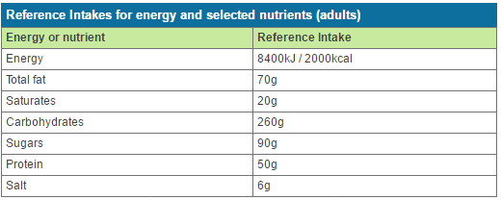

*Source: Food and Drink Federation (2017)*

***3.5.3 Method Outline***

There are two distinct types of machine learning: supervised, and unsupervised learning. Supervised learning is the machine learning task of inferring a function from labelled data (Maetschke et al., 2014); a popular supervised learning implementation is classification. In contrast, unsupervised learning is a type of machine learning algorithm used to draw inferences from datasets consisting of input data without labelled responses (Mathworks, 2017).

The difference between supervised and unsupervised learning is the labelling of test data. For this study, there are two possible approaches. The first would be to use the percentage contribution to reference intake for a person’s diet and run a cluster analysis to determine patterns between the test data. This would involve running a hierarchical clustering algorithm to find the number of clusters between the dataset. Patterns can therefore be formed based on this data. Once the number of clusters has been defined, a k-means clustering algorithm could be performed. Significantly, this uses unsupervised learning.

The second approach would be to label the test data depending on the person’s daily food intake. Mifflin et al. (1990) created a predictive equation for resting energy expenditure (REE) from data derived from 498 healthy subjects, both male and female between the ages of 19 and 78. The equation is highlighted in figure 1:

***Fig. 1****: Mifflin-St Jeor Resting Metabolic Rate (RMR) equation*

Frankenfield et al. (2005) conducted a systematic review of all these equations and found Mifflin-St Jeor’s to be the most reliable, predicting resting metabolic rate (RMR) within 10%. Notably, RMR is the minimal rate of energy expenditure per unit time at rest (Blundell et al., 2012). Therefore, people who are slightly active must therefore eat more calories.

Calculator.net (2017) offers a tool for calculating the RMR a person needs to have per day to maintain, gain and lose weight over a one week period. They use the above formula but also consider how active a person is – multiply the result by 1.2 for little to no exercise, 1.4 for light exercise, 1.6 for moderate exercise, etc. Then, a person will need 500 calories over their RMR to gain a pound, and 500 calories under to lose a pound. For example, a male of height 5ft 10 inches (177cm) who weighs 140 pounds (62kg) and is lightly active needs 2,250 calories to maintain their weight, 1,750 calories to lose a pound and 2,750 to gain a pound (after a week, respectively). Therefore, diets can be labelled as high risk and low risk contributors to weight gain depending on whether their calorie intake is high (depending on their RMR, of course).

The decision as to which approach to use will be made following the collection of training data – as the technique to be used will depend heavily on the data available to this researcher. Considerably, regardless of which technique to use, a regression model will be created which will aptly estimate the relationship between the foods the user eats and the amount of weight they have lost / gained.

In terms of the software that will be used, SPSS could be a useful tool. It comes with the capabilities to run regression and k-means clustering on a dataset with ease, as well as agglomerative (hierarchical) clustering and classification tools. However, SPSS is expensive, proprietary software that this researcher does not have access to. Therefore, it cannot be used. As an alternative, R is a free, open-source programming environment which will allow for the same tasks to be computed. Subsequently, this will be used to find which people fit into which cluster / classify that person’s weight gain prediction.

4. Development

This section outlines the development stage of the project. It details the development of the Android application (including the process of creating the user interface, database, and integration of the open-source, free-throw game), as well the subsequent gamification elements present within the app.

***4.1. User Interface***

Shortly after completing the research and planning, the development of the project commenced. This chapter begins with an overview of the app’s development. As was the case in the project plan, the user interface of the app was the first thing to be built – subsequently based on the wireframes developed on Mockingbot.com (see appendix B, figures 38 and 39).

Android Studio was the platform used to develop the app, utilised because of its immense capabilities and array of built-in libraries – which made the design and implementation of the app much easier. Notably, Android Studio divides the app into its layout and its functionality, using XML and Java, respectively. For the layout, resources were made to represent colours, strings, styles, and dimensions that would be used throughout the app (these sit within the “res” folder of the Android Studio project).

In Java, a LayoutCreator class and ViewCreator class were created for when layouts and views (i.e. TextView, ImageView, EditView, etc.) had to be instantiated programmatically, meaning the front end of the app would be created based on what existed in the Java code. This was used, for example, for generating the foods that appeared in the diary. This was necessary because it is unknown how many foods the user will add to their diary – if a fixed number of TextViews were added to the layout, this would restrict the user if they intended to add more than what was allowed. Therefore, the TextView would be created whenever a user added a diary, so that the diary could be of a variable length.

The following subchapters will go into detail regarding some of the user interface features.

***4.1.1. Navigation Drawer***

Navigation around the app was pertinent to its usability. Subsequently, a navigation drawer (or side menu) was added, with its implementation made easier by the built-in libraries in

Android studio. The IDE has an activity titled NavigationDrawerActivity, which comes with an already existing side menu. This was customised to include the features present within the app, and to include the username of the user who is currently logged in (see figure 2). Moreover, the items that existed with the navigation drawer could be selected (code which was editable within the activity in Java).

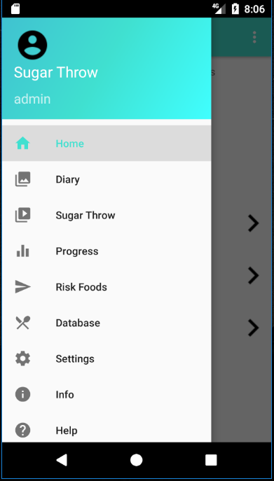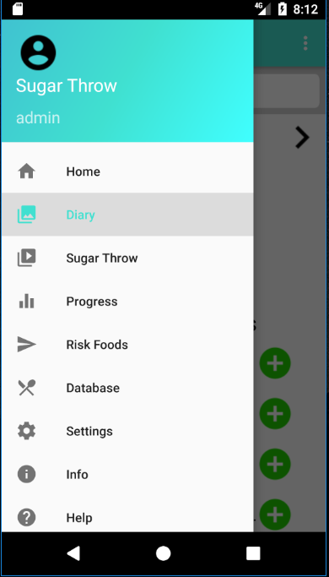

***Fig. 2:*** *Navigation Drawer*

***4.1.2 HUD and Toolbar***

To give the user more information on the home page of the app, a heads-up display (HUD) was created. The HUD includes the amount of sugar the user has left on their daily allowance and the total number of points they have obtained thus far.



***Fig. 3****: Toolbar and HUD*

Another significant feature in the image above (figure 3) is the toolbar. Not only was this used for access to the navigation drawer (toggling the burger navigation icon), but also included the title of the activity and an options menu (seen on the right of the above image). Considerably, therefore, both the toolbar and the HUD are an important element of the user interface.

***4.1.3 ImageSlider***

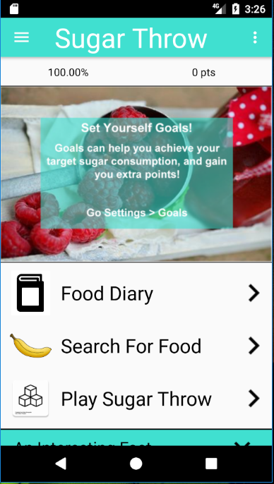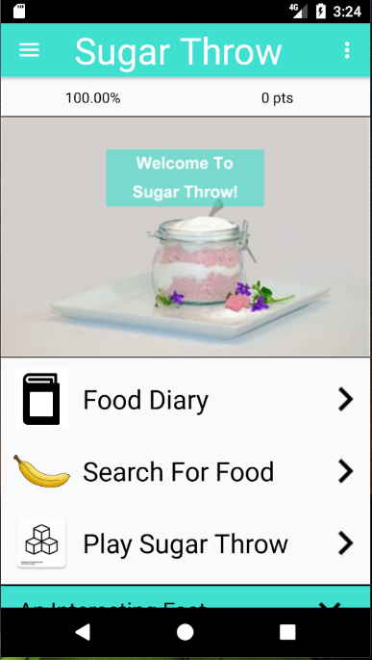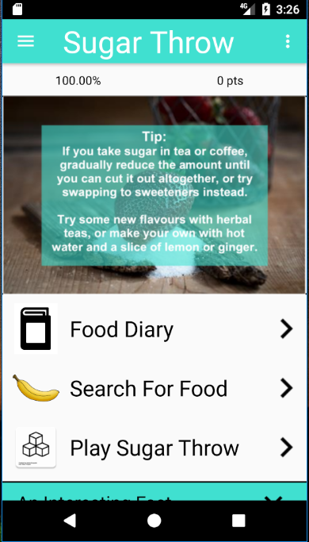The ImageSlider class inherits the methods and functionality from the PagerAdapter class. The latter class is used to allow multiple images to occupy one space (thereby mimicking an image carousel). Subsequently, if the user swipes left or right on the “hero image” on the homepage, another image will appear (see figure 4).

***Fig. 4****: Three Images within the ImageSlider*

***4.1.4 MPAndroidChart Library***

Much of what exists in the standard Android Package Kit (APK) was sufficient for this app. However, the APK is limited when it comes to creating charts and graphs (which were necessary for displaying the daily intake and usage streak in a graphical form). Subsequently, the MPAndroidChart library – developed by Jahado (2017) – was added to the list of dependencies.

As highlighted in figure 5, the MPAndroidChart library was used to represent data in a graphical form, i.e. pie charts and line graphs. The pie charts show the percentage intake and amount left a user has for a particular food group (sugar, salt, etc.). The line graph shows the number of foods the user has logged over the last five days. Considerably, these elements make the app less mundane and subsequently more appealing to the user.

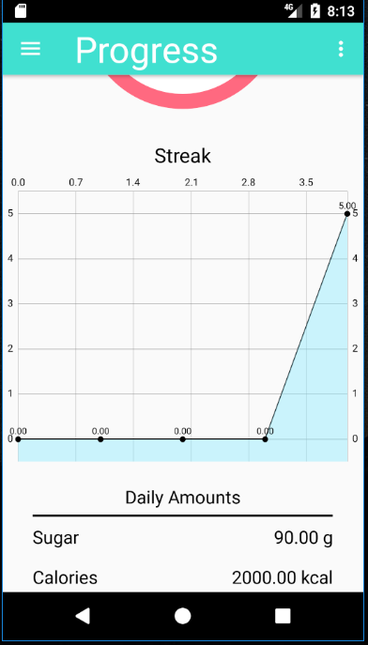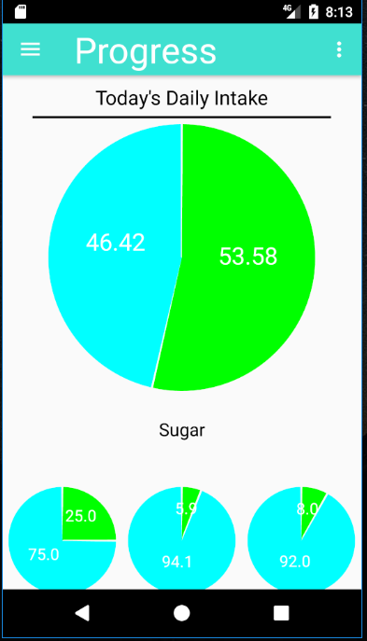

***Fig. 5****: Uses of MPAndroidChart Library*

However, a problem with the MPAndroidChart library is its issue with memory leaks. Whenever charts are created using the library, they are never freed and aren’t collected by the garbage collector. This caused an “Out of Memory” error if the user opened the “Progress” activity several times. Subsequently, this was a bug that needed to be fixed during system testing (see section 4.8).

***4.2 Nutritionix API***

In order to obtain food items, and nutritional information corresponding to those items, an online food database was needed. The Nutritionix API offered free access to over 500,000 grocery items from Canada, the US, and the UK (Nutritionix, 2017). Although there are certainly more effective and richer APIs that exist online, Nutritionix offered the minimal requirements necessary for a project of this calibre. It was therefore the ideal choice.

***4.2.1 How the API worked***

The Nutritionix API allows calls to be made to the database via a unique API ID and API key. The database is then queried using these unique identifiers, in which a URL is returned. At this URL, sits the results of the search, which exist within a JSON obejct (see figure 6).

Then, a way to parse the contents of the webpage was needed so as to use the search results in the app. Subsequently, the Google Volley library was utilised. Volley is Google’s networking library which allows for HTTP requests to be made (Android, 2017c). On response of the request, subsequent processes would occur. However, in some cases, the volley request returns an error, so is therefore given an “error listener”. This was used so that if, for any reason, there was an error in the HTTP request, the app wouldn’t crash.

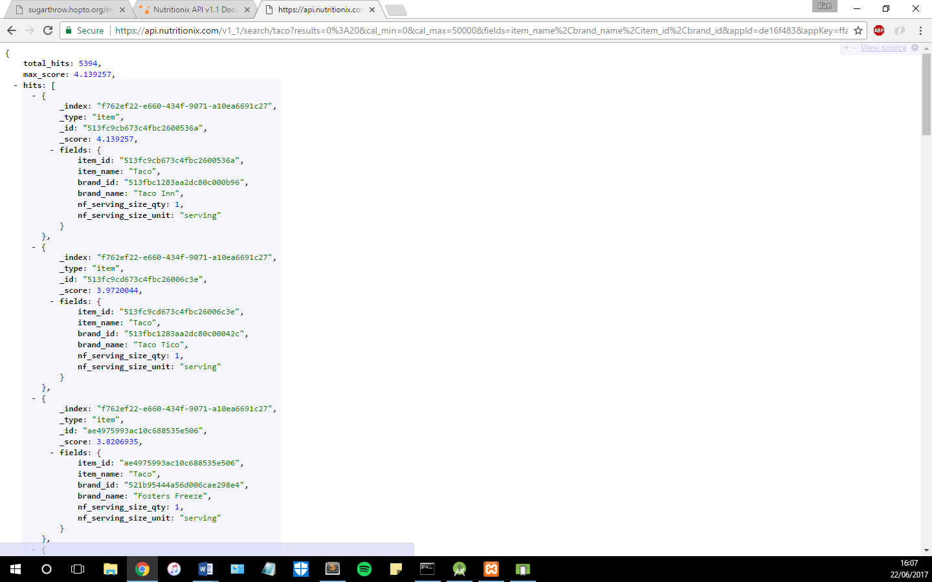

***Fig. 6****: JSON Object returned by API*

In the request method, Volley uses the URL provided to send a HTTP request. Once this request responds, the response is passed into a String which, in this case, is an array of JSON objects.

***4.2.2 Returning Results to the App***

The String which is returned on response of the Volley HTTP request is an array of JSON objects, provided the search returned any results. If the search did not return any results, then the app would display “No Results”, as shown in the left image of figure 7. Otherwise, the results are read into a 2D array list of Strings, containing the item name, item id, and brand name of the products returned. This was done by using a JSONArray object (while the JSONArray still had hits to be read, the results would be parsed using a JSONObject, which would contain the identifiers needed in a string).

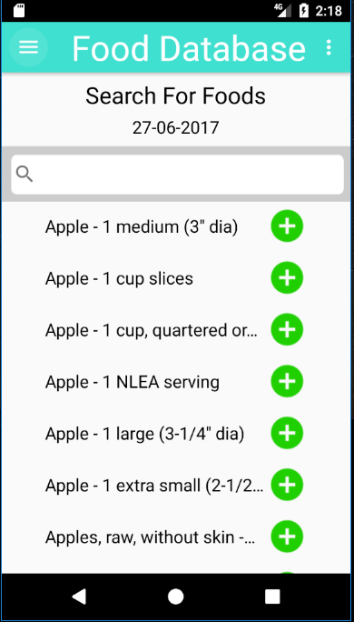

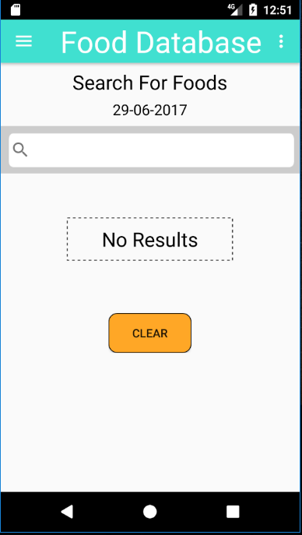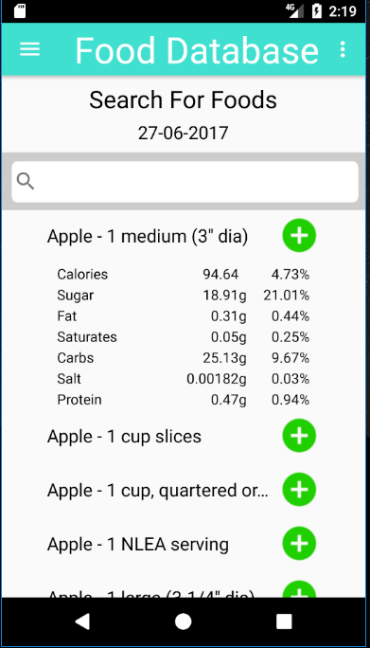

***Fig. 7****: Food Database Search Activity*

Notably, the item id needed to be recorded in order for UPC searches to occur. UPC searches are those in the Nutritionix API which include the nutritional information for the corresponding food item. These requests were similar to those used to search the API, but instead of a search term, the URL is passed the item id. Like the search request, the returned response is a JSON array, but with just one JSON object.

***4.2.3 Limitations of the API***

A significant issue with the Nutritionix API is that it limits the number of API calls an account is allowed to have per day (unless a monthly subscription is purchased). It limits the number of searches to 5000, and item views (views of nutritional content) to 200.

Search calls are used whenever a search request is made within the app, i.e. the user uses the search on the Food Database Activity or on the Diary Activity. Item view calls are used whenever a food item is added to a user’s diary, or the content is looked at when a food is clicked (see right image of figure 7).

The graph below (figure 8) shows the usage of the API over a day. Noticeably, the number of item views (dark orange) surpasses 200. This resulted in the API no longer being usable for that day. This wasn’t a problem when using the app for personal use, but would become a significant issue when the user studies take place. Subsequently, a method to resolve this issue was to mimic “caching” the data.

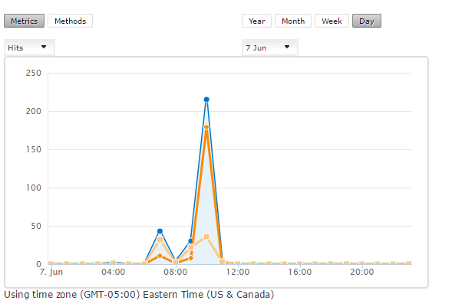

***Fig. 8****: The Daily Usage of API*

***4.2.4 Caching the Data***

The purpose of a cache is to store data, which is accessed regularly, away for future use (Chaplot, 2016). Therefore, to counteract the limits on API usage, a local database was used so as to “cache” the data. It effectively stored foods that were used most often, so calls to the API weren’t necessary. The creation of the database is highlighted in section 4.3.

To mimic a “cache”, whenever a food item was added to a diary or the contents looked at, the information for that food would be stored in a local database. Then, when that food was searched for again, its contents would be referenced from the local database, therefore not making a HTTP request and using an API call. This process would prove to be vital for allowing multiple usage of the API.

***4.3 SQLite Database***

A database is pivotal to the app in order to record the user’s daily food intake. As a result, an SQLite database was created. SQLite databases are known to be useful for embedded systems (such as apps), as they are simple and server-less (Bhosale et al., 2015).

***4.3.1 Creating the Database***

The database was created locally on the command line using SQLite3. The five tables created were “User”, “Food”, “Diary”, “Goals”, and “Sugar”. A schema is highlighted in the appendix C, figure 40.

The database created on the command line was copied into the assets folder of the Android project. Then, a Connector class was used to establish a connection with the SQLite database that sat within this folder. This class inherited the SQLite operations from the SQLiteOpenHelper class that exists within the Android SDK. “Connector” is a Singleton class in which the database connection is accessed by various activities throughout the app.

The “Execute” class is used for querying the SQLite database. It is passed an initialised Connector object, allowing inserts, selects, updates, and deletions to be performed on the database. The “SqlQueries” class was used to store all the SQL queries used in the app. All these queries include placeholders (“?”) so that the app isn’t vulnerable to SQL injection.

***4.3.2 Diary and Food Database***

The SQLite database is used a considerable amount throughout the app. One of the more important uses is in the Diary Activity. The database holds the foods the user has eaten on a given date (queried from the Diary table). The user can also use the arrows to the top of the activity to view diaries from other dates.

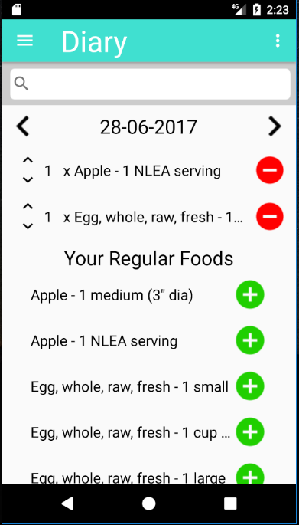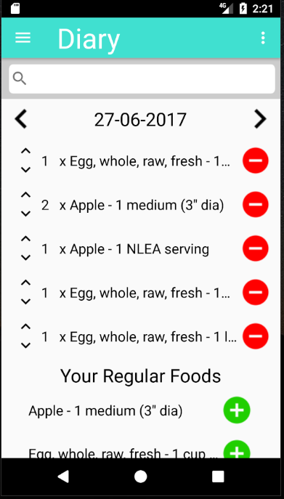

***Fig. 9****: Diary Activity*

A regular foods section is a feature that proves to exist on many dieting apps. It is often the case that a user eats certain foods more than once a week, and this section saves them having to search for the food every time they want to add it.

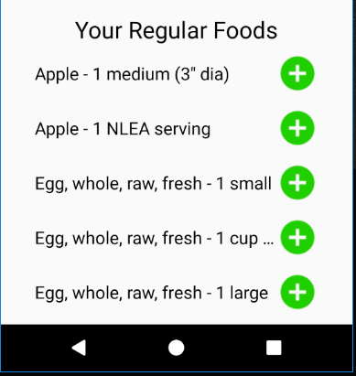

***Fig. 10****: Regular Foods Section in the Diary Activity*

Finally, the database is used within the Diary Activity for inserting / removing foods. The user can press the “minus” buttons to remove foods from their diary, or the “plus” button that sits within the regular foods section to add that food to their diary. The contents of the diary will then be updated. The user can also increase or decrease the quantity of that food by pressing the arrows to the left of the food name (see figure 11).

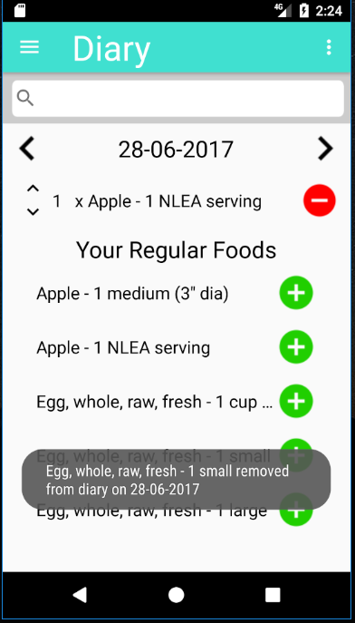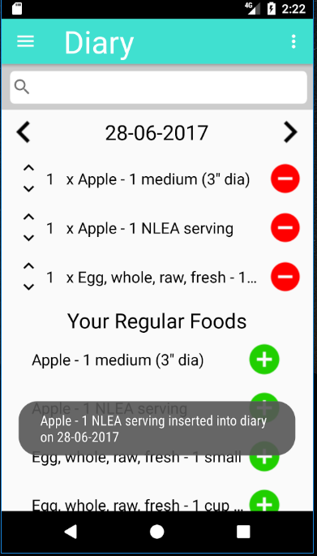

***Fig. 11****: Food being added and removed from Diary*

In addition, as previously noted, the contents from the Nutritionix API are cached into the local SQLite database to save on API calls. This is the main purpose of the database for this activity, bar adding foods to the user’s diary.

In some cases, the app needed to wait until the request had finished before it could process certain things. This is an instance of an asynchronous task. In order to prevent certain processes from running until other processes had finished, an Interface titled “ServerCallBack” was created, containing the method “onSuccess()”, which would return the response string once the HTTP request had completed. In the case of inserting into the local database, this prevented any null objects being processed before the HTTP request had returned any of the data.

***4.3.3 Progress and Goals***

In the Progress Activity, the SQLite database is utilised for a number of components. For instance, the user’s points (obtained from the “User” table) are displayed at the top of the activity. Moreover, the daily intake per food group the user is allowed is altered based on the “Goals” table – if the user has indeed set daily goals (see figure 12).

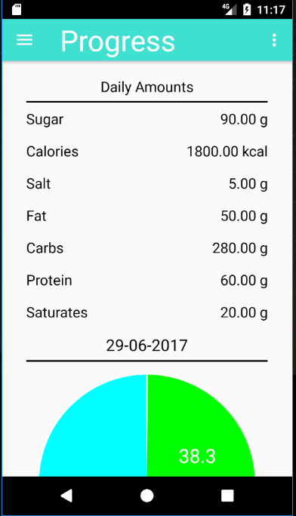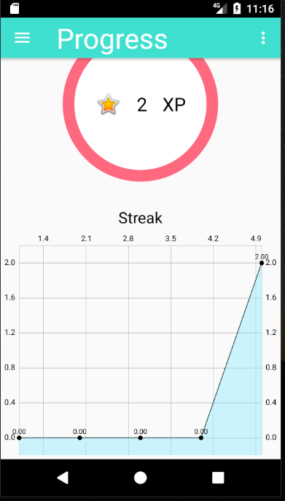

***Fig. 12****: Progress Activity*

Furthermore, the total intake and amount left is calculated depending on data that exists in the database. The database is queried for the sum of each food group on a given date and the percentage contribution for that food group is determined within the FoodContentsHandler class. This class is responsible for any process involving the nutritional content of food; it is used considerably for giving personalised feedback (see section 4.6.2).

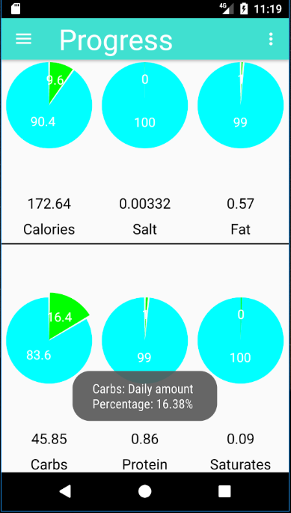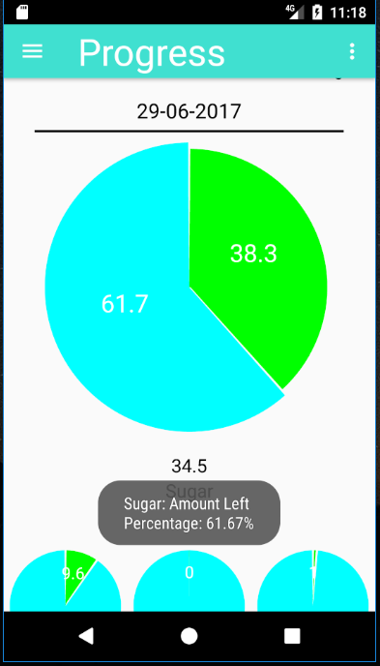

***Fig. 13****: Pie Charts showing Daily intake in Progress Activity*

In addition, a subtle feature that exists in the app is the ability to view the Progress of different dates in the user’s diary. If the user clicks on the date within the Diary Activity, they will be sent to the Progress Activity and displayed the nutritional content for that date. If they simply navigate to the activity from the Navigation Drawer, they will be displayed their progress for the current date.

***4.4 Online Database***

Having a database that is local to a user is adamant for recording their data and determining their daily food intake. However, this data is only local to their device, making the data inaccessible to this researcher. Subsequently, a place to store the data online was needed. This subsection outlines the development of an online database that was accessible from a static IP address.

***4.4.1 Creating a Server***

In order for this data to be accessible, it needed to exist somewhere on the web. This researcher therefore had two options: the first would be to purchase a domain name and push contents onto a website; the other would be to create a home server. After much deliberation, the latter option was chosen.

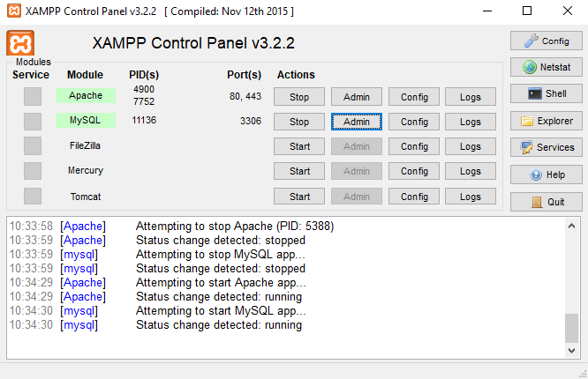

***Fig. 14****: The XAMPP Server Client Interface*

The process began by first downloading the XAMPP server client. XAMPP is a free, open-source cross-platform web server package consisting mainly of an Apache HTTP server and MariaDB database (Apache, 2017). The inclusion of a MySQL server made this the ideal software to use for this project.

As only the user data and the total amount of food a person has eaten on a given date was required, the database consisted of just two tables, “Users” and “Contents”. The database was created using phpMyAdmin – software provided by XAMPP that handles the administration of MySQL over the web (*ibid.*).

Next, the “httpd.conf” file was edited to point to a folder titled “server” on this researcher’s home computer. Now, anything within this folder could be accessed by entering the IP address of the local network. In order for the contents of the folder to be accessed by outside users, the router needed to be configured to allow HTTP requests. Port forwarding was set up so that the computer acting as the server handled any requests on port 80.

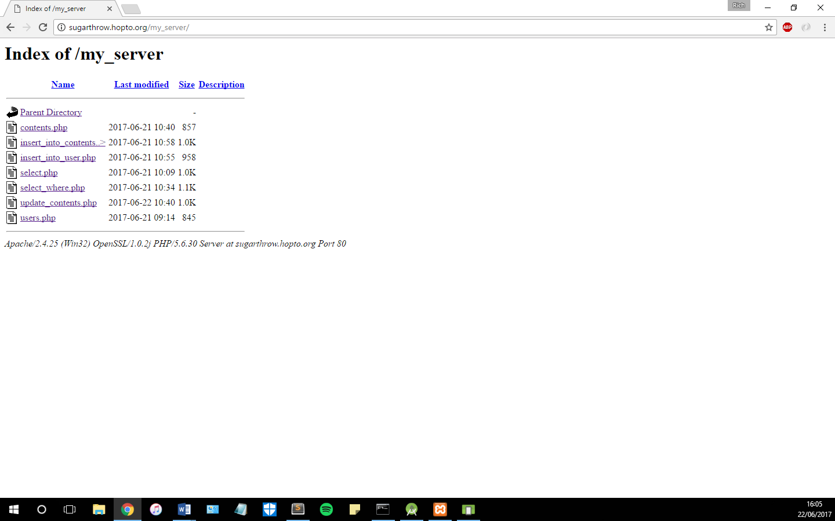

***Fig. 15****: The Contents that sit on the Server*

As Windows Firewall blocks HTTP requests direct to the IP (to prevent malicious attacks), this needed to be bypassed by adding an inbound rule to allow any requests on port 80 to be accepted. Now, the contents of the “server” folder could be accessed by any computer by entering the network’s IP.

However, IP addresses aren’t always constant; they change whenever the router is reset and then randomly allocated. As a result, a dynamic domain name was needed. Subsequently, a free domain name was obtained and the Dynamic DNS Update Client was downloaded. This software links the domain name to the IP address, so that when the IP changes, the contents can still be accessed by reaching the same domain name. The server could now be accessed by going to <http://sugarthrow.hoptp.org/> (**Note**: only when the server is running).

***4.4.2 Adding Content to Server***

After everything for the server had been set up, PHP files were created to query and make changes to the online database. The “contents.php” and “users.php” files simply select all rows from the corresponding tables (“Contents” and “Users”, respectively) and display the results in a JSON Object.

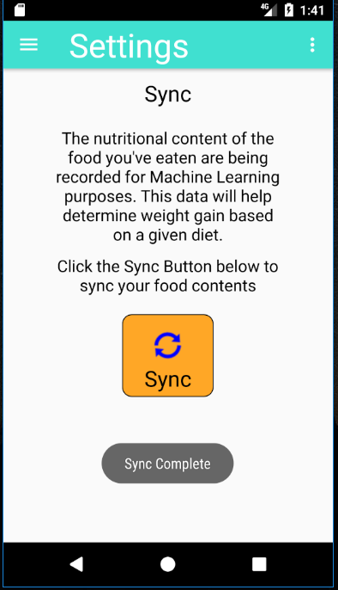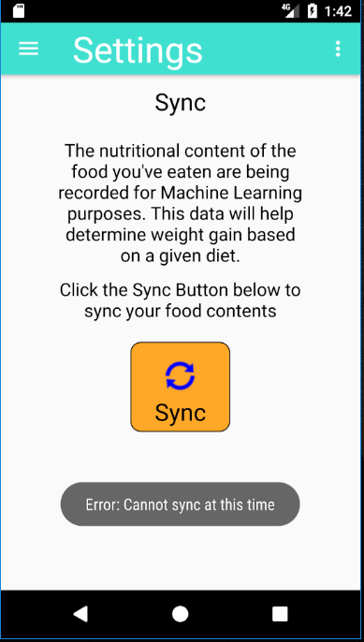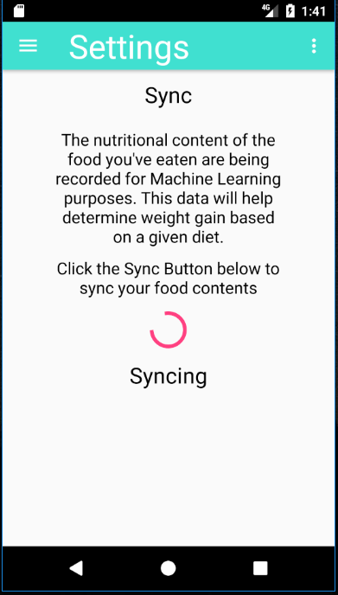

***Fig. 16****: Syncing to Online Database*

The “select_where.php” and “select.php” files returned JSON Arrays of JSON Objects so that the data could be processed in Android studio. In some cases, these were used to query the database to see if data existed. A particular problem that arose when using these files to query the data was that if no results were returned, Android studio would throw an error. This would often be because the app would try to parse a JSON Object that didn’t exist. Subsequently, this was altered in the PHP files. If the query returned no rows, then a JSON Object would be created containing the value “null”, thereby solving the error. The “insert_into_user.php” and “insert_into_contents.php” files were used whenever insertions to “User” and “Contents” were necessary.

To allow the user to sync their data to the online database, a Sync activity was added under Settings. If the user clicks the “Sync” button, a progress bar will appear, letting the user know that the app is syncing. Considerably, as the server is just a home computer that isn’t on 24/7 (like most servers), a user could sync their data when the server wasn’t running. Thus, methods which made requests to the server had an error handler which would return a message saying “Error: Could not sync at this time”, followed by the name of the error, e.g. Network Timeout Error (see figure 16).

This was used to safeguard the app and prevent it from crashing whenever the server (computer) was turned off. If the server is running, and there are no errors with the sync, then the user will be displayed a message saying “Sync complete”.

***4.4.3 Logging in and Signing Up***

The concept of multiple users on one device was made possible by having the local SQLite database. A user would be able to log out of their account and sign into another one if they chose to. Signing out of an account would then result in the Login screen appearing (see figure 17).

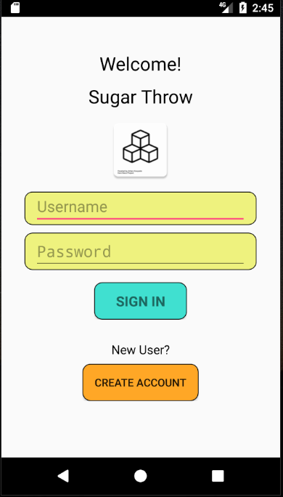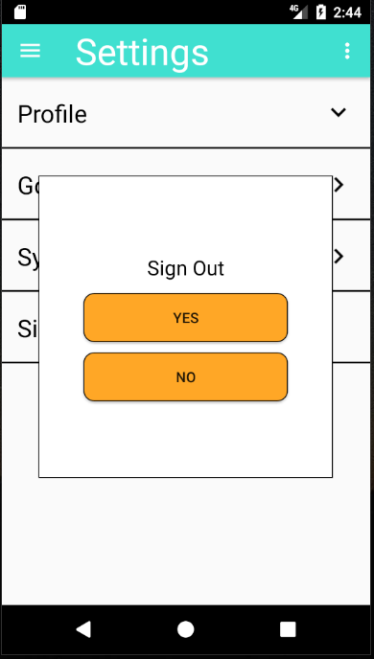

***Fig. 17****: Signing out and Logging In*

The database would be used to check whether the username exists and that the password corresponding to that user was correct. If any of these prove to be invalid, the user is prompted by an error (see figure 18). If the user does not already have an account, they could create one by clicking the “Create Account” button at the bottom of the Login Activity.

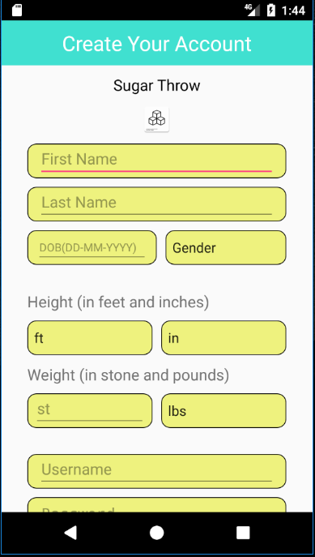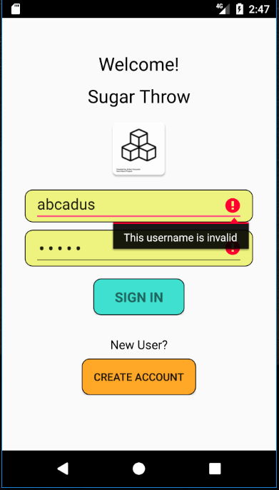

***Fig. 18****: Error on Log in and Sign Up Page*

To sign up for an account, the user enters detail which are then inserted into the “User” table. Before the account is created, the app first checks to see if the username already exists on the online database. If it is in fact unique, then the user’s details are added to both the local and online database.

When the user opens the app, the LoginActivity appears on the screen (figure 18). To prevent users from having to login each time they opened the app, the “SaveSharedPreferences” class was created. This class is used to determine whether the user is logged in or not. If the user is logged in, they will be redirected to the homepage. Otherwise, they will remain on the login page.

***4.4.4 Hashing passwords***

For security, passwords were hashed using an algorithm developed by Balkar (2013). Storing passwords in plain text is not good practice, and is a severe security risk. Subsequently, the password entered by the user when they sign up is hashed into a string which is then stored in the database. Then, when the user wants to login using their password, the password is hashed once more and if this matches the hash that exists in the database, the user will be allowed to enter.

***4.5 Unity Game***

As previously stated, a core concern with dieting apps is that they lack the ability to keep the users engaged over long periods of time. Subsequently, this app has utilised a pre-existing free-throw game to thereby increase engagement and encourage continued use.

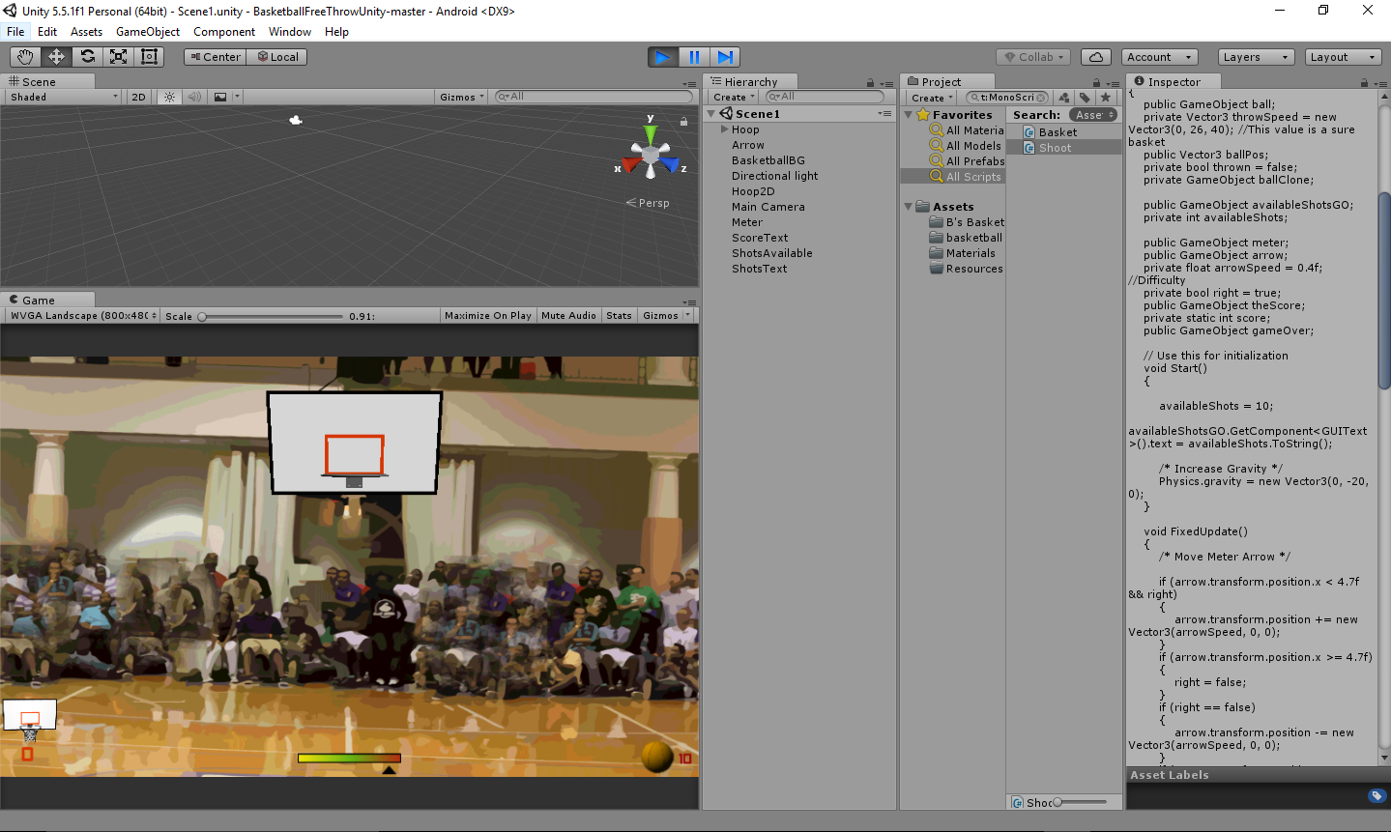

***Fig. 19****: The Basketball Game in Unity*

The Unity game was created by Yanez (2014) and is a simple, basketball, free-throw game. The user is given a basket and is required to press the screen when the arrow is in the green to try and score points. The game was edited so that the number of shots available to the user could be changed and the difficulty increased.

***4.5.1 Problems with the game***

The game was built in Unity so that it could be embedded into the Android app. The Unity classes were added as dependencies to the Android project and the “build.gradle” script was updated to allow the Unity game to run.

Initially, the purpose of embedding the app was to allow the user to use the points they’d obtained as the number of throws they have within the game. The issue with this is that by exporting the game to Android, it becomes embedded, and communication between the two cannot therefore exist. A way to work round this would have been to build the game inside Android, rather than embedding it from Unity.

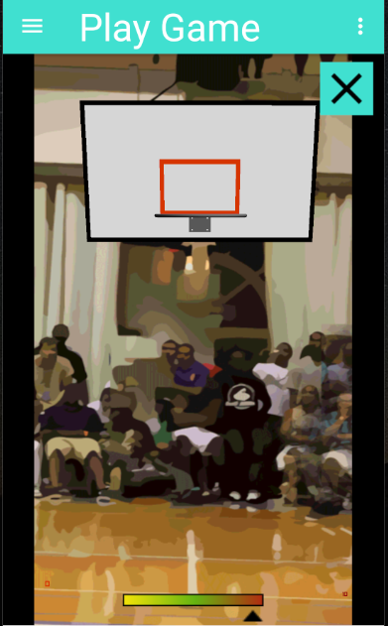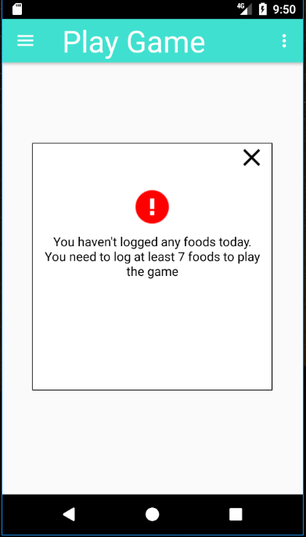

***Fig. 20****: The Game within the App*

However, the look and functionality of the game wasn’t pivotal to the success of this project, so the time spent doing this would have been time wasted. Instead, the game is used as a means of entertainment for the users of the app, in which they can only play if they have logged foods on that day. Consequently, the concept of using the game as an engagement mechanism is still relevant.

***4.5.2 The Game inside the App***

As previously mentioned, the game is embedded into the Android app. When the user clicks “Play Sugar Throw” on the home page or navigates to Sugar Throw from the Navigation Drawer, the app will determine whether the user is allowed to play the game by looking at the number of foods they have logged for that day. If they have logged fewer than 7 foods, they will be prompted with a message (seen in figure 20).

If they have in fact logged enough foods for that day, they will be allowed to play the game. The game will load and the user is given 10 shots. At any time, the user can press the cross in the top right corner to exit the game, or use the navigation drawer to pause and leave the game screen. Pressing the close button results in the application being killed. Therefore, the Unity game needed to be made a separate process from the app itself. By doing this, when the game is “killed” (exited via the cross), the entire application doesn’t close as well, just the game activity.

***4.6. Gamification Elements***

To reiterate, gamification has been known to influence behaviour. The gamification elements within this app correspond to the ones discovered in the literature review: goals; feedback; and self-monitoring. This subsection highlights how these elements are incorporated into the app.

***4.6.1 Goals***

The ability to set goals is important to a gamified app. Therefore, this app contains its own activity that sits within Settings (Settings --> Goals). In the activity, the user is given the option to set daily and weekly goals. The daily goals refer to the intake of each food group (i.e. sugar, calories, etc.) a person can have each day. The weekly goals refer to the intake of sugar and the percentage reduction of sugar they wish to have over a week.

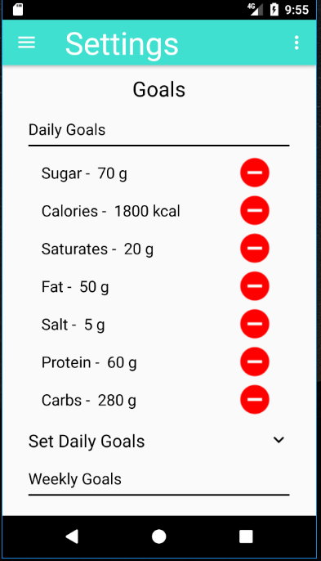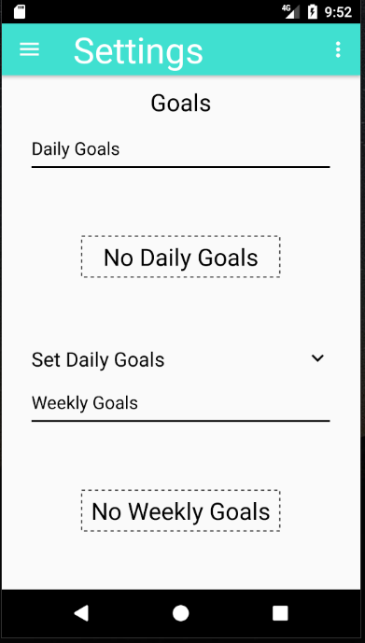

***Fig. 21****: Goals Activity*

When the user adds a goal, it appears within their “Goal Diary”. If they have no goals in their diaries, then “No Daily Goals” or “No Weekly Goals” is displayed. These goals can also be removed by clicking the “minus” button.

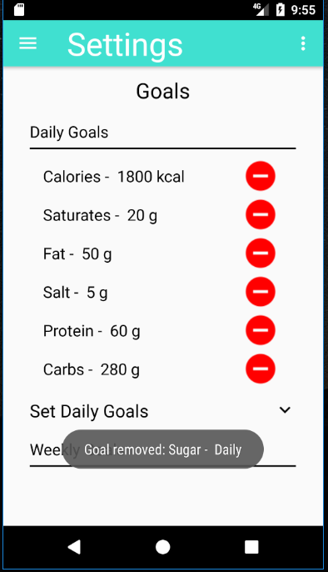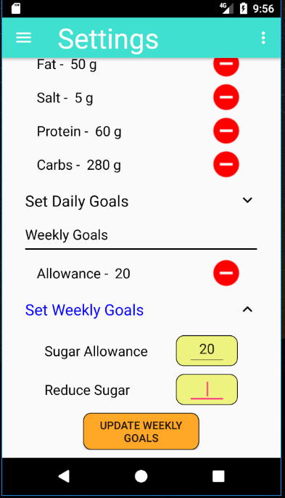

***Fig. 22****: Adding and Removing Goals*

The purpose of goals is to give the user a target to reach. By reaching this target, they are rewarded with 5 points, and if they exceed their goal / don’t achieve their goal then they will be deducted 5 points. This, in turn, gamifies the concept of goals and encourages the user to improve their habits.

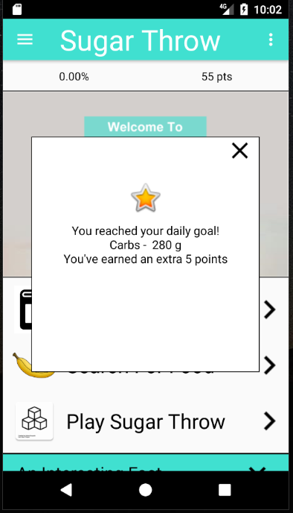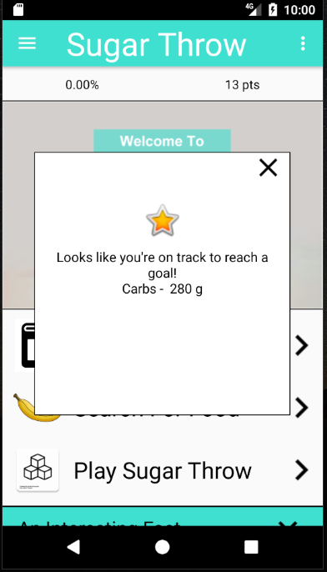

***Fig. 23****: Feedback for Reaching Goals*

***4.6.2 Feedback***

Feedback is a key technique utilised in gamified smartphone applications to facilitate change. As noted in the literature review, studies found that feedback should be tailored to a person’s characteristics in order to be effective. Subsequently, feedback in the app appears in a number of forms relating to how the students use the app; feedback popups appear whenever: a user has exceeded a daily amount of a food group; a user has achieved a goal; a user has failed a goal; a user has logged foods for multiple days in a row; or a user is eating a lot of a particular food that is unhealthy, to name a few.

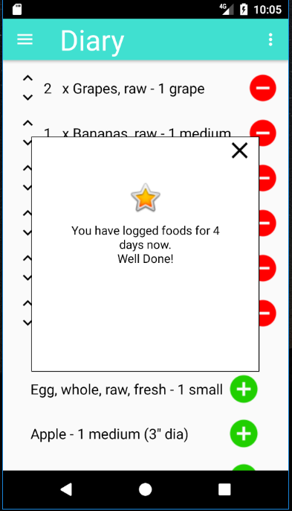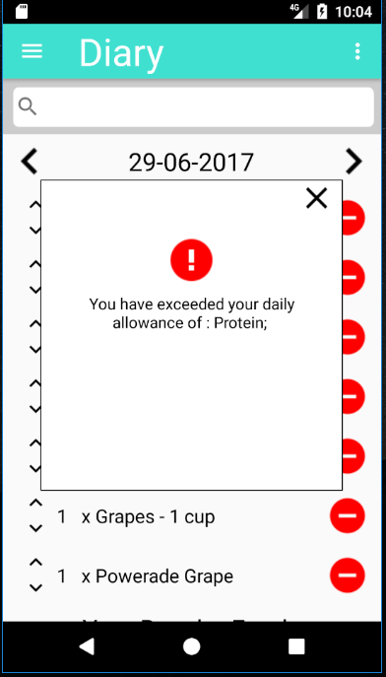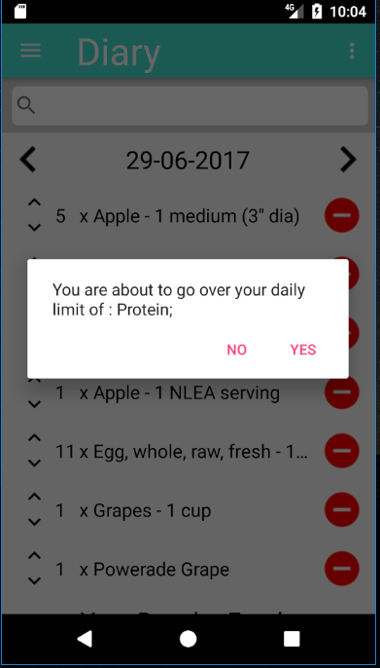

***Fig. 24****: Dialog Box and Feedback Popups*

The idea behind the feedback popups is to give the user an understanding of their progress. They are given both negative and positive feedback, denoted by the image that appears atop the popup (see figure 24).

Another example of feedback within the app is the use of dynamic content. This dynamic content (which is controlled by the “DynamicContentHandler” class) changes each day to give the user a different number of health tips, facts, and meals (see figure 25).

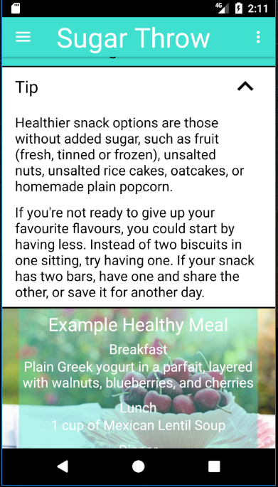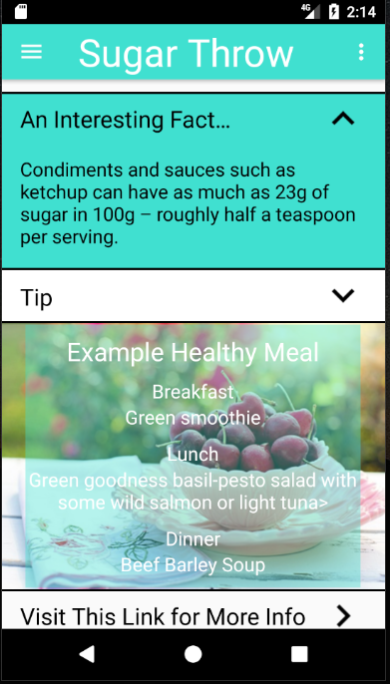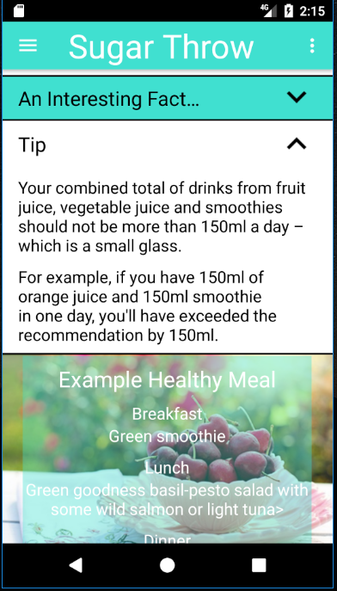

***Fig. 25****: Dynamic Content on Home page*

Finally, achievements are used as yet another means to give the user personalised feedback. For example, if the user reaches 100 points, they are given the “Intermediate” achievement (see figure 26). Achievements are one of the most commonly implemented gamification techniques (Lister et al., 2014) and are used in this case to show how well the user is doing – thereby giving them positive reinforcement.

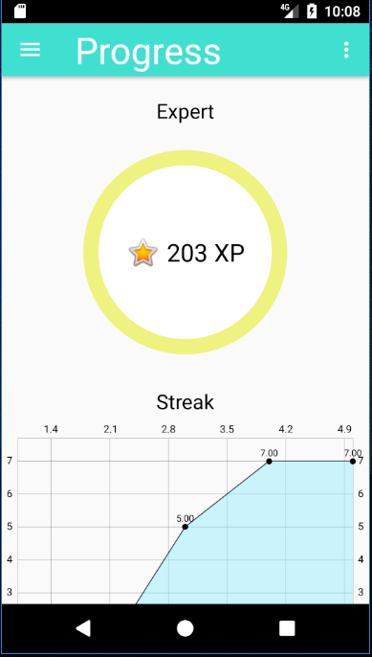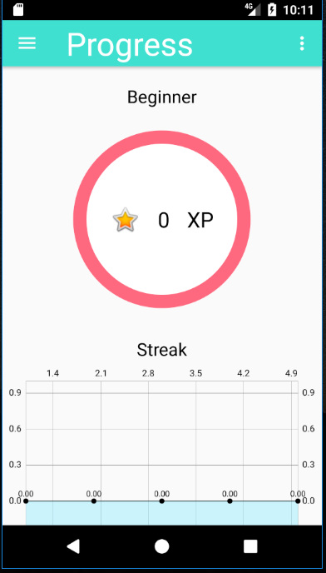

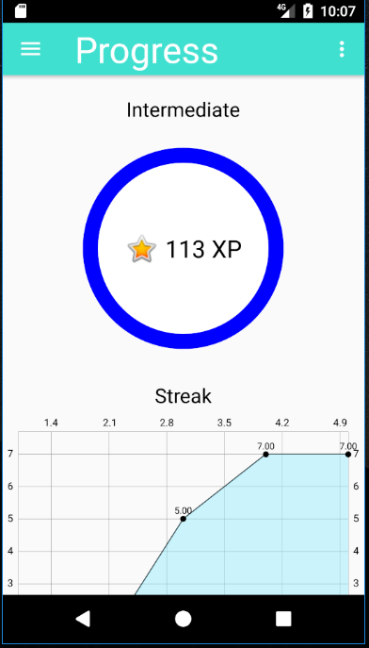

***Fig. 26****: Achievement Badges in Progress*

***4.6.3 Self-Monitoring***

Finally, the third gamification technique utilised throughout the app is self-monitoring. Self-monitoring is engrossed in the app; the user is required to monitor their own diets, enter their own food intake, etc.

This is highlighted in the Diary Activity, where the user is required to add or remove foods they have eaten. They are also responsible for the percentage intake of the foods they have logged, as shown in the Progress Activity. Giving the users complete control over their eating habits and the monitoring of their diets is expected of any dieting app.

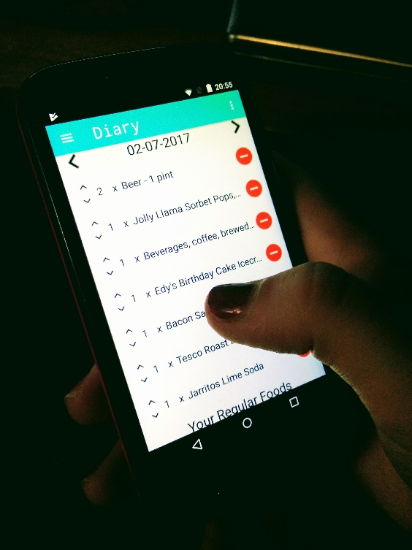

***Fig. 27****: Picture of User Acceptance Testing*

***4.7 User Acceptance Testing***

Following the completion of the user interface and most of the app’s functionality, user acceptance testing was performed. The user acceptance test (UAT) is the final stage of testing in application software development, tested in the real-world by the intended audience (Leung & Wong, 1997).

Two students were selected to test the app. As this was simply an exercise to determine how usable the app was, the interviews were very informal. Each student was asked to play around with the app for 15 minutes; navigating around the app, adding foods they’d eaten, playing the free-throw game, etc.

From these user tests, a number of flaws in the app were noticed. Most noticeably, there were issues when it came to adding / removing foods, changing dates, updating goals, and anything else involving pressing a button. The users had difficulty knowing whether they had in fact pressed these buttons. This feedback was taken on board and the app went through a subsequent stage of development. In this stage, more “Toast” messages were implemented to give the user an idea of what they were doing, i.e. when a food was being inserted / removed (as shown in figure 28).

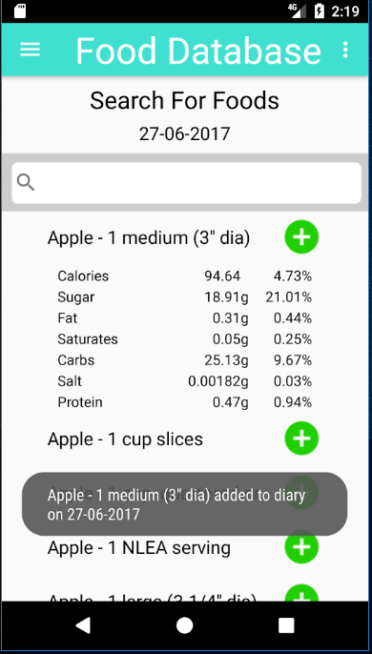

***Fig. 28:*** *Toast Message*

Table 2 identifies further feedback given by users and how the app was subsequently improved as a result.

**Table 2:** Feedback given in User Acceptance Testing

|  |  |
| --- | --- |
| **Feedback** | **How app was improved** |
| “Display the total of each food group as well as the percentage in Progress” | The respondents felt that the percentage intake of a food group was difficult to understand, and that they wished to see the actual amount of each food group also. Subsequently, the daily amount appears in “Progress”. |
| “Needed to be made clear what the [HUD] was displaying” | Respondents were unsure what the HUD was showing. Therefore, the app was changed so that if a user clicks on the text in the HUD, a “Toast” message will appear to give the user information on the number of points they have left and the daily percentage of sugar they have left |
| “Be able to change your weight in Profile” | Finally, respondents felt that, as this was a dieting app, they wanted to be able to change their weight if possible. As a result, users can now click “Weight” in the Profile dropdown in Settings and change their weight accordingly (see the rightmost image in figure 29). |

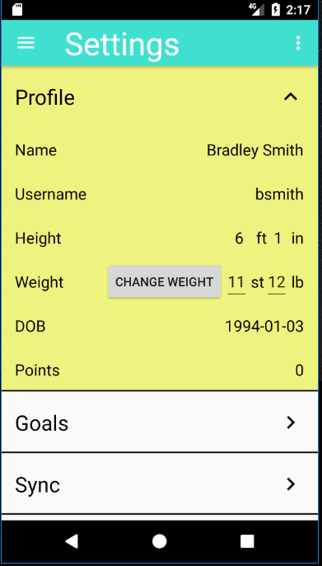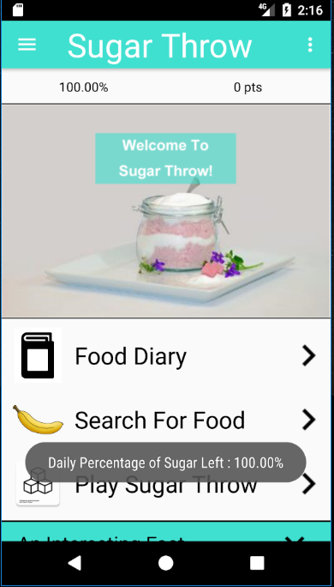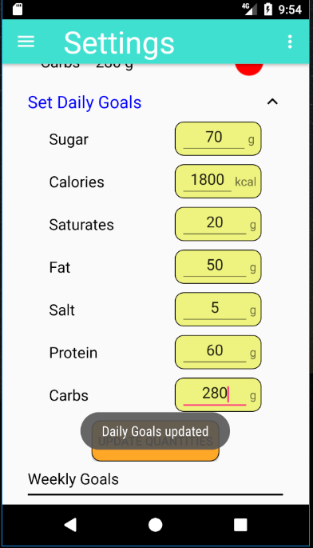

***Fig. 29****: Changes Made to App following User Acceptance Testing*

In addition, a significant amount of time was set aside to improve the look and feel of the app. Much of the feedback from the user acceptance testing was that the design didn’t look very appealing. If the interface is not appealing, it is not engaging. As this project aims to improve attitudes towards healthy eating by making an *engaging*, gamified application, a number of changes were necessary. Consequently, a lot of time was invested in UAT and making these changes as user engagement was a key determinant of this project.

***4.8 System Testing***

Following the user acceptance testing, some system tests were completed to determine whether all the functionality of the app worked properly. System testing of software or hardware is testing conducted on a complete, integrated system to evaluate the system's compliance with its specified requirements; it verifies the correspondence between the overall system and its specifications (Baresi & Pezze, 2006; Tutorials Point, 2017). Some notable bugs found during regression tests are included in table 3.

**Table 3**: Bugs discovered during System Testing

|  |  |
| --- | --- |
| **Bug** | **How the bug was fixed** |
| Search not working | The issue here was that the hash map titled “searchKey”, which was used to remove duplicates in the search entries wasn’t cleared when the user made another search. The searches would then be deleted and the user would not be able to see any results. Clearing the table subsequently solved this problem. |
| Sync not working | The Sync button that exists in the SyncActivity was meant to show a progress bar when clicked. This worked when the server was on, but not when the server was off. This was subsequently fixed by assuring that the progress bar appeared regardless of whether the server was on or off. |
| Back button not updating diary | Whenever the user pressed the back button on their Android device and this resulted in them being in the Diary activity, the results in the Diary would not have been updated (if food had been added before the back button was pressed). Subsequently, a method was created in the MainActivity (and therefore inherited by all other activities) which meant that the previous activity was launched when the back button is pressed. To do this, the previous activity (as a string) was added to the Intent object that was passed to each activity. |
| On Track to Reach Goals Popup displaying wrong Goal | The feedback popup which let the user know they were on track to reach a certain goal was displaying the wrong goal. For example, if the goal was Sugar – 90g, it would show Fat – g. This was simply because the order of the Goals in the SQL query did not match the ones in the hash map – a quick change in the order of the hash map solved the issue. |
| Memory Issue for MPAndoridChart Library | A considerable problem with the MPAndroidChart Library is that it is prone to memory leaks. This is because the charts are never freed when an activity is paused (i.e. opened but not finished). As a result, whenever the activity is loaded, new charts are created and the old ones are never freed, which causes a severe amount of memory to be used. To combat this, whenever the user leaves the activity (which calls the onPause() method) the activity was killed – by calling the finish() method. |

Once all these bugs were rectified, the app was ready to be deployed so that the user studies could take place.

5. USER STUDIES

This section highlights the steps taken to evaluate the effectiveness of the app in facilitating behavioural change. It summarises the method in implementing the user studies and analyses the subsequent results obtained from these studies.

***5.1 Pilot Study***

The final stage of the research design process is to eliminate problems through pilot testing. Pilot testing involves testing the study on a very small sample of respondents for the purpose of improving the process by identifying and eliminating potential problems (Malhotra & Birks, 2006). Through this, certain errors in the wording of questions, the gathering of data, and possible usability issues with the app can be identified. This is a crucial evaluative criterion for this project as these problems may be avoidable in the actual user study.

For this project, the user study was tested on 2 respondents. These respondents were asked to undergo the study (for a day instead of a week) and then asked to fill in the questionnaire provided to them. The process proved to be fundamental to the project, as the respondents felt the questionnaire was difficult to understand and that more time was needed for them to get used to the app. Subsequently, this feedback was taken on board and was considered for when the actual user studies took place.

***5.2 Gathering Data for User Study***

The data collected from the user studies was based on a sample of the student population, as it is often unnecessary – or impossible – to obtain statistics from an entire census (Thompson, 2012). As there is no sampling frame and time is very limited, a quota sample of 10 students will be used.

Quota sampling is a non-probability sampling techniques that uses two stages (Malhotra & Birks, 2006). The first stage consists of developing control categories, or quotas, of population elements – for this study, these are male and female university students between the ages of 18 to 22. In the subsequent stage, sample elements are based on convenience or judgement (*ibid.*).

An email was sent round asking if any students would like to take part in the study. The 10 students that were selected were based on the researcher’s judgement – which in turn were based on the following criteria: the age of the student, degree specification, and the year they are currently in (i.e. first year, second year, third year). This was to make the sample more representative.

Something not predicted, was that certain users would not have up-to-date Android operating systems (OS). Thus, the SDK was lowered from Marshmallow (SDK 23) to Lollipop (SDK 22), to allow these students to use the app.

In the first stage of the process, users were given the app and asked to enter the food they ate the day before. In doing so, guidance was given to them on how to use the app, and they were also given the opportunity to get used to the app (something that was noted from the pilot study).

Once they had completed this exercise, the amount of sugar they had eaten was recorded (see table 4). This acted as a test variable and showed the amount of sugar they consumed before using the app. The cohort was then split into two groups of 5 by random – each user was given a unique id number, and 5 numbers were then pulled out of a hat. These 5 users were then asked to set goals, whereas the others were advised not to – so the differences between the groups could be analysed.

The users were then sent away to use the app for a week. A week later, the cohort was gathered once more and asked a series of questions based on their experiences. The questions provided were both open-ended and closed-ended. Closed-ended questions have a fixed number of answers, giving the users less freedom to communicate their experiences but gives the researcher data which is easily quantifiable, and therefore easy to measure. These questions deployed five-point Likert scales. A Likert scale is an ordinal, measurement scale with five response categories ranging from “strongly disagree” to “strongly agree” that requires respondents to indicate a degree of agreement or disagreement with each of a series of statements related to the stimulus objects (McNeill & Chapman, 2005). The content of these questions was loosely based around the effectiveness of the three gamification techniques: feedback; goal-setting; and self-monitoring. The questionnaire given to respondents is shown in appendix D.

* 1. ***Analysis of Results from User Study***

This section outlines the analyses that took place on the data gathered from user studies. As most of the data was quantitative, and therefore measurable, R was the programming software of choice.

***5.3.1. Results for Objective 1***

This subsection outlines the project’s first objective and analyses the sugar consumption of each user to make inferences based on this objective.

***SRA1: Identify the impact of healthy eating app on reducing sugar consumption within a sample of students over a period of 1 week prior versus 1 week after***

For this objective, the amount of sugar the users had eaten prior to using the app (the day before they logged their own foods) was recorded. Then, the amount of sugar they ate on the last day of logging foods was recorded. Subsequently, a comparison between these two values was made.

***Figure 30****: Line Chart showing a respondent’s sugar levels throughout the week*

However, the problem with this method is that on the first day of recording the foods they had eaten, this may have been a particularly “sugar heavy” day, likewise with the final day. Therefore, the average amount of sugar consumed over the week was compared with the first day and the last day, to give a clearer idea of the changes in the users’ sugar levels.

Figure 30 highlights a graph denoting the change in sugar levels for one of the users. Noticeably, the amount of sugar the user had varies significantly throughout the week, but there is in fact a significant decrease in the amount of sugar they had at the beginning of the week compared to the end of the week.

More conclusively, table x identifies the differences in sugar levels for each user, and determines whether there has been a significant reduction 1 week prior to using the app versus 1 week after.

Significantly, the results in table 4 highlight a positive change in behaviour; All but one user had less sugar on the last day than their average throughout the week. As a result, one could infer that, for the most part, there was a change in the amount of sugar users had 1 week prior to using the app versus 1 week after.

**Table 4:** Amount of Sugar Students had Prior to Using App

|  |  |  |  |  |  |
| --- | --- | --- | --- | --- | --- |
| **Student** | **Before using the app** | **After using the app** | **Avg. for Week** | **Diff (Before and Avg.)** | **Diff (After and Avg.)** |
| *Student 1* | 115.64g | 58.09g | 52.18g | -55.53 | 5.901 |
| *Student 2* | 45.58g | 17g | 70.42g | 21.73 | -53.42 |
| *Student 3* | 70.79g | 45.93g | 60.61g | -8.90 | -14.68 |
| *Student 4* | 23.89g | 17.12g | 33.54g | 8.44 | -16.42 |
| *Student 5* | 20.39g | 19.7g | 38.94g | 16.23 | -19.24 |
| *Student 6* | 86.94g | 36.9g | 58.08g | -25.25 | -21.18 |
| *Student 7* | 82g | 77.14g | 79.75g | -1.97 | -2.61 |
| *Student 8* | 68.37g | 65.42g | 67.53g | -0.74 | -2.11 |
| *Student 9* | 60.89g | 35.44g | 42.41g | -16.17 | -6.97 |
| *Student 10* | 50.62g | 33.21g | 53.99g | 2.97 | -20.78 |

***5.3.2. Results for Objective 2***

This subsection outlines the project’s second objective and identifies the differences between those who set goals and those who didn’t.

***SRA2: Identify the impact of goal-setting on producing behavioural change for half the cohort***

For the second objective, the difference in sugar levels between those who set goals and those who were advised not to was observed. In doing so, the impact of the goal-setting feature of the app could be evaluated.

The data in table 5 highlights the differences in sugar levels between those who set goals and those who didn’t. Interestingly, the mean (average sugar consumption for each group) for those who set goals is considerably lower than for those who didn’t (51.65g and 61.52g, respectively). Moreover, the median, lower and upper quartiles are also lower for this group.

**Table 5**: Differences in Sugar Consumption between the two groups

|  |  |  |  |  |  |  |  |
| --- | --- | --- | --- | --- | --- | --- | --- |
| **Group** | **Goals** | **Mean** | **Median** | **LQ** | **UQ** | **IQR** | **Range** |
| *Students 1 – 5* |  | 51.65g | 52.18g | 38.94g | 60.61g | 21.67g | 36.88g |
| *Student 6 – 10* |  | 61.52g | 58.08g | 53.99g | 67.53g | 13.54g | 37.34g |

LQ = Lower quartile, UQ = Upper quartile, IQR = Inter-Quartile Range

To give a clearer representation of the differences in sugar levels, a boxplot was created in R using the following code:

boxplot(Sugar ~ Group, data = mydata, main=“Difference in Sugar Levels: Goals vs No Goals”, xlab=“Group”, ylab=“Sugar Consumed(g)”)

The following (figure 31) boxplot was subsequently created:

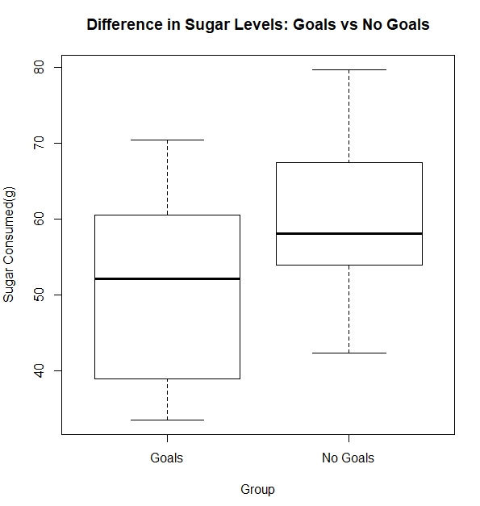

***Figure 31****: Boxplot showing differences in sugar levels between two groups*

Figure 31 highlights the differences between the two groups (goal setters and non-goal setters). Noticeably, as previously stated, there is a much lower mean for those who set goals against those who didn’t (51.65g versus 61.52g). Based on these results, one could infer that there is a significant difference in sugar levels between these two groups. This researcher has therefore concluded that goal-setting appears to be an effective gamification technique.

***5.3.3 Results for Objective 3***

Finally, this subsection highlights the project’s third objective and identifies which gamification technique had the greatest impact on “claimed” behavioural change.

***SRA3: Analyse which gamification technique has the greatest impact on claimed behavioural change***

For this objective, the results of the questionnaire were collected and collated so that inferences could be made as to which technique had the greatest impact on *claimed* behavioural change – that is, whether the user themselves believe that the app has been effective in influencing a change in their behaviour.

Firstly, as the quantitative questions were divided into categories (goals, feedback, monitoring, and effectiveness), an average Likert score for these categories was recorded, per user. For instance, the scores from the four questions relating to goals were totalled and averaged to give an overall, standardised score referring to the user’s response relating to setting goals.

The standardised score taken for the three questions referring to the effectiveness of the app acted as the dependent variable, with the other three categories representing the independent variables. A regression analysis was then run on these variables to determine the significance of the relationship between the app’s effectiveness and the three gamification techniques.

Considerably, as not all users were required to set goals (and therefore were not required to answer the questions referring to goal-setting), two separate regression analyses were implemented – one for just goal-setting, and one for feedback, and self-monitoring.

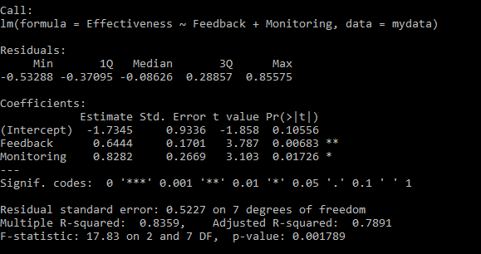

***Figure 32****: Results from Statistical Regression Analysis (Feedback and Monitoring)*

For feedback and self-monitoring, the linear regression model was entered into R using the following code:

fit <- lm(Effectiveness ~ Feedback + Monitoring, data = mydata)

summary(fit)

This yielded the results shown in figure 32.

Both variables are significant – falling within the 5% confidence level. Noticeably, feedback falls within the 1% confidence interval, therefore making it the more significant of the two techniques. It could then be inferred that there is a significant relationship between both feedback and self-monitoring on claimed behavioural change, with feedback having the stronger relationship.

For goal-setting, the linear regression model was again entered into R using the following code, which yielded the results shown in figure 33:

fit <- lm(Effectiveness ~ Goals, data = mydata)

summary(fit)

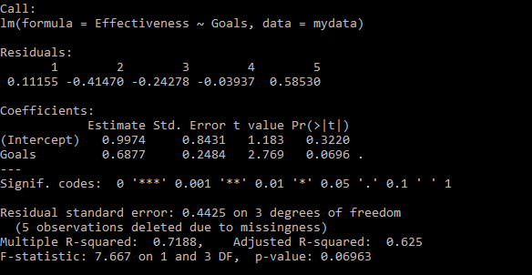

***Figure 33****: Results from Statistical Regression Analysis (Goals)*

Interestingly, the results show that goal-setting is in fact not significant in impacting *claimed* behavioural change (it falls within the 10% confidence interval, which is not enough evidence to prove that there is a relationship between the variables). Therefore, this would imply that goal-setting was not effective in facilitating behavioural change, despite evidence on the contrary being provided earlier.

Table 6 describes the results from the regression analysis, highlighting the significant p-values in grey and the insignificant values in red. Table 7 highlights the standard error and R-squared statistics for the two analyses. R-squared is a statistical measure of how close the data are to the fitted regression line. For the feedback and monitoring regression analysis, the R-squared statistic is 83.59%, suggesting that there is a strong fit; even with an adjusted r-squared of 78.91% (adjusted based on the number of predictors in the model), one could infer that the model explains most of the variability of the response data around the mean. For the goals analysis, however, the R-squared and adjusted R-squared are 71.88% and 61.25%, respectively. This still implies that the model explains variability of response data around the mean, but is considerably lower than the first analysis.

**Table 6:** Results from Regression Analysis

|  |  |  |  |  |
| --- | --- | --- | --- | --- |
| **Feedback and Monitoring** | | | | |
|  | Estimate | Std. Error | t value | Sig. |
| (Intercept) | -1.7345 | 0.9336 | -1.858 | 0.10556 |
| Feedback | 0.6444 | 0.1701 | 3.787 | 0.00683 |
| Monitoring | 0.8282 | 0.2669 | 3.103 | 0.01726 |
| **Goals** | | | | |
|  | Estimate | Std. Error | t value | Sig. |
| (Intercept) | 0.9974 | 0.8431 | 1.183 | 0.3220 |
| Goals | 0.6877 | 0.2484 | 2.769 | 0.0696 |

**Table 7**: Validity of Regression Analysis

|  |  |  |  |
| --- | --- | --- | --- |
| Analysis | Standard Error | R-Squared | Adjusted R-Squared |
| Feedback and Monitoring | 0.5227 | 83.59% | 78.91% |
| Goals | 0.4425 | 71.88% | 62.5% |

To summarise, feedback proved to be the most significant of the three gamification techniques, with self-monitoring yielding a significant relationship with claimed behavioural change and goal-setting having an insignificant relationship with the control variable.

***5.4 Qualitative Results***

This section outlines the qualitative feedback received from the user studies. It outlines the comments given by respondents and how these comments were taken on board for future considerations. A table of their responses is shown in the appendices (tables 10 – 13).

***5.4.1 What Respondents Liked***

From the questionnaire, respondents were given the opportunity to give feedback on the app: what they liked; what they felt could be improved; any problems they had with the app; etc. For instance, a user felt that having to keep track of the food they were eating meant they would take time to consider how healthy certain foods were. Other users simply used the app to look up the number of calories, sugars, etc., in certain foods before deciding to eat them.

Moreover, users felt that the feedback they were getting helped them understand what they were doing right and what they were doing wrong. Having the app tell them when they are about to go over a certain food group meant they could plan their meals accordingly. Furthermore, they liked the idea of gaining points, with one user saying they tried not to go over their daily allowance just so they could get as many points as possible.

In addition, many users liked that the content on the homepage changed each day. It meant they would open the app just to see what the newest tip of that day would be. In doing so, this encouraged them to use the app more often.

***5.4.2 What Respondents Felt Could be Improved***

The purpose of giving open-ended questions was to give the users the chance to provide constructive feedback. For instance, one user felt that swiping to delete foods would have worked better than just having a button. Moreover, users felt that switching back and forth between the diary and their progress took a lot of time, particularly if they wanted to see their progress on previous days.

In addition, certain users felt that the game within the app got a bit tedious after a couple of days. They felt that for the first few days, they would try to log foods just so they could play the game. However, after 3 or so days, they didn’t need to play the game anymore as it wasn’t challenging enough; they weren’t coming back because of the game, but just to keep track of the foods they’d eaten. Thus, users felt that the game was an effective means of engagement, but needed to be more challenging; being able to remember their high score and having that high score displayed on a leader board would have made the game a lot more competitive.

As a result of this feedback, recommendations will be made (see section 6.5 in conclusions).

6. DISCUSSION

This section summarises the project thus far, and provides conclusions on the effectiveness of the Smartphone app in facilitating a change in behaviour.

* 1. ***Summary of Analysis and Findings***

From the literature review, three gamification objectives were formed:

* **SRA1**: Identify the impact of a healthy eating app on reducing sugar consumption within a sample of students over a period of 1 week prior versus 1 week after.
* **SRA2**: Identify the impact of goal-setting on producing behavioural change for half the cohort
* **SRA3**: Analyse which gamification technique has the greatest impact on claimed behavioural change

The amount of sugar users had prior to using the app was recorded and the differences before and after were compared. Inferences were made and it was found that there was in fact a reduction in sugar consumption for most of the respondents after using the app, thereby completing the first objective (**SRA1**).

For the second objective (**SRA2**), half the cohort was asked to set goals and the difference in sugar levels between those who did and those who didn’t was recorded. Based on the average amount of sugar for these two groups, it was implied that setting goals resulted in users having lower amounts of sugar, thereby completing the objective.

Finally, the results from the user studies were used to determine which of the three gamification techniques had the greatest impact on claimed behavioural change (**SRA3**). After running a regression analysis on the three gamification techniques against the claimed effectiveness of the app, it was found that feedback was the most significant contributor, followed by self-monitoring. Goals, on the other hand, was found to have a non-significant relationship with claimed behavioural change, therefore meaning that the users felt that setting goals would not influence their behaviour.

***6.2 Conclusions Drawn from Analysis***

This subsection aims to shed light on the results of the user studies, giving reasons as to why the results turned out the way they did.

As previously stated, feedback was found to be the most significant contributor to claimed behavioural change of the respondents. This may be because (as identified in the literature review), people see personalised feedback as a form of positive reinforcement which, in this case, would influence them to log foods more regularly or in fact try not to exceed their daily allowances.

Self-monitoring would also be regarded as significant to claimed behavioural change as many users felt that having the ability to monitor their own behaviour encouraged them to eat healthy. The reason why self-monitoring wasn’t as significant as feedback may be because it wasn’t as apparent to the user that this was a gamification technique, whereas the popups which were given to them were very clearly signs of feedback.

Adversely, goals were found to be a non-significant contributor to claimed behavioural change, despite there being evidence to suggest that those who set goals had a lower amount of sugar over the course of a week compared to those who didn’t. It is possible that users believed that setting goals did not influence their behaviour, when in fact it did. The questionnaire was a means of identifying what the user felt about the app, and how it influenced them to eat healthy – hence “claimed” behavioural change. So why would respondents not find goal-setting a significant contributor in influencing behaviour? Put simply, it may be because the users weren’t given the opportunity to set more advanced goals – they could only set the total of each food group per day and a total for the number of sugar throughout the week. Based on questionnaire feedback, had they been able to set other goals, for example: to reduce their weight by 2 pounds, they possibly may have seen these as more effective in facilitating healthy behaviour.

***6.3 Project Implications***

This subsection outlines how the research from this project can benefit the field of gamification and, therefore, HCI (Human Computer Interaction).

Based on this study, it is implied that feedback is the most significant of the three gamification techniques utilised. Future researchers can consider that feedback is the most significant technique and customise their projects around this. By understanding what is the most significant technique in facilitating a change in behaviour, these researchers can personalise their own studies to delve deeper into how feedback influences behaviour.

Moreover, researchers and developers for dieting apps will benefit from knowing that using a game within the app proves to be an engaging tool which encourages respondents to continue using the app, but may have to change how it works. The app also helped users understand the issues of eating too much sugar, and that an effective use of gamification can in fact help to encourage students to cut down on their sugar consumption.

* 1. ***Limitations***

This subsection outlines the limitations with the research design and subsequent data collection from the user studies. It also details certain limitations of the app.

***6.4.1 Project Limitations***

Certain problems often arise during data collection of a study. A common problem which affects a lot of research is the issue of response error. Response error is a non-sampling error which arises from respondents who do respond but give inaccurate answers, or whose answers are mis-recorded or mis-analysed (Malhotra & Birks, 2006). This may have been an issue when collecting results from the user studies – respondents may not have responded as they intended. As a result, there are underlying implications of the research design which are out of the researcher’s control.

Moreover, the choice of sampling technique puts into question the validity of the study. Quota sampling is a non-random sampling technique, and one in which respondents were selected based on convenience or judgement after control groups are identified. Use of this technique means that an element of bias is present; respondents weren’t selected completely at random, therefore making the sample less representative of the entire population.

In addition, the size of the sample may have been too small to warrant a significant contribution to the field of gamification. Had this researcher had more time and resources, more respondents could have been interviewed (as was the case with prior studies on gamification).

Finally, another limitation of this project was the inability to change the basketball game to suit the theme of the app. Having done so would have resulted in a much clearer reason as to why it was included. This issue would have been rectified by creating a game within Android Studio, thereby allowing communication between the app and the game to be possible.

***6.4.2 App Limitations***

Developing the app in such a short space of time meant that the memory issues couldn’t have been resolved. Certain care is often needed to ensure that apps don’t use up too much RAM, which is often the case when the app has to load images, bitmaps, etc. For this app, the images created would, typically, be too large for commercial applications. Had more time been given, the size of images would have been reduced to allow for more memory to be freed.

Moreover, as noted previously, the MPAndroidChart Library has a significant memory leak issue. With more time, another chart library would have been implemented, or the current library would have been modified so that the charts are deleted when the activity ends.

In addition, as numerous respondents felt that the game wasn’t as engaging as it could have been, time would have been put aside to improve it.

***6.5 Recommendations***

If given more time, one would seek to repeat the user studies so as to increase the reliability (perhaps using a test-re-test reliability approach). This is an approach for assessing reliability in which respondents are administered identical sets of scale items at two different times, under as nearly equivalent conditions as possible (Malhotra & Birks, 2006). This would also improve the reliability of the goal-setting tests – by giving the same cohort the ability to set goals and not set goals, there is no question as to whether the variation between respondents in different groups has affected the outcome. Moreover, a further recommendation for future improvements would be to use more respondents.

In terms of the app, there are a number of ways that the functionality could be improved, some of which were suggested by respondents in the user study. One such recommendation was to use a swipe feature to remove foods, rather than having a button. This is made possible in Android Studio via the “RecyclerView” class, which allows users to swipe in a certain direction to remove contents from the layout.

Furthermore, in terms of improving the overall essence of the app, voice recognition software and a barcode scanner could be added to further improve the user experience and make it easier for users to log foods. Android offers the ability to add voice capabilities using free-form speech input – it stores a request code as an integer using the ACTION_RECOGNISE_SPEECH action, making it possible to recognise certain words (Android, 2017d). Moreover, the barcode scanner could be added using the “Scandit” SDK, which stores a variety of barcodes in a database which can then be accessible via the phone’s camera (Scandit, 2017).

In addition, another improvement would be to allow the user to move between their progress, similar to how they move between diaries. This is simply because there was overwhelming feedback regarding the time it took to move between the amounts of food the user had on a particular day to another. Although this is a simple feature, it will most likely improve the user experience and encourage them to use the app more often.

7. Extension Task – Machine Learning

As an extension task, this project had an objective to utilise a machine learning algorithm and determine whether a user could gain weight given a certain diet. This section outlines the process of gathering training data and utilising this to develop a linear regression equation that would predict a person’s weight gain / loss given their diet.

The objective, as stated in the methodology and design phase of this project, is to evaluate the effectiveness of the app’s machine learning functionality in predicting the weight gain of users over a given period. The first task was to gather training data and then find a machine learning algorithm to run the data through.

***7.1 Method***

This section outlines the methodology behind implementing the machine learning functionality of this android app, including how data was gathered and how the machine learning algorithm (linear regression) was used on said data.

***7.1.1 Linear Regression***

Looking at the machine learning objective, predicting weight requires prediction of a number. Therefore, linear regression was the ideal algorithm for this task. Linear regression is an approach for modelling the relationship between a scalar dependent variable y and one or more explanatory variables, denoted as x (Alavifar et al., 2012).

***7.1.2 Gathering Data***

The training data was gathered by asking respondents from the user studies to sync their apps with the online database. This would result in the total of each food group they had eaten for each day being pushed onto the server. This data was then collected and put into a spreadsheet to be analysed. To find the number of calories, sugars, etc., required per user, the St. Mifflin-Jeor equation was used.

This is an equation which utilises someone’s height, weight, age, and gender to determine the number of calories they require per day. Then, the 50/30/20 diet plan was utilised to determine the amount of carbohydrates, protein, and fat someone requires (Styles, 2017). This states that 50% of someone’s calories should come from carbs, 30% protein, and 20% fat. It is also suggested that 9% comes from saturates, and 15% from sugars (10% natural and 5% added sugars). 1g of carbs is equivalent to 4 calories, as is 1g of protein, and sugar. 1g of fat and saturated fat is equivalent to 9 calories (*ibid.*). Thus, to determine the amount of sugar someone needed in grams, 15% of the user’s calories were calculated and then divided by 4.

Once the number of calories, sugars, etc., were calculated for each user, the content from the server (which sits in the “contents.php” file) were observed and recorded. Then, the percentage contribution to each user’s daily intake was calculated, e.g. if a user required 1597.7 calories per day and ate 1163.2 calories, this would equate to 72.81% of their calories. These would act as the feature variables (inputs).

Machine learning can either be supervised or unsupervised. Supervised learning is the machine learning task of inferring a function from labelled data (Maetschke et al., 2014); classification is a popular supervised learning technique, and this functionality aims to classify a person’s change in weight given their diet. Using the St. Mifflin-Jeor equation, it was possible to determine the amount of weight gained / lost based on the inputs. Thus, the data was labelled.

The labelling of data was based on the weight change from the original weight. It is well known that someone needs 3500 calories (excess or deficit) a week to change their weight by 1 pound (which is equivalent to 500 calories a day). Therefore, 1 divided by 3500, divided by the difference between their actual calories consumed and recommended calories equates to a change in weight:

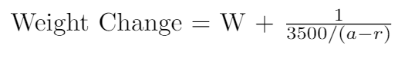

(**Key**: W = current weight; a = actual amount consumed; r = recommended amount)

This was then worked out for each food group (as each food group can be converted to calories). 1g of sugar, carbs, protein, and salt equates to 4 calories, therefore the formula is:



1g of fat and saturated fat equates to 9 calories, therefore the formula for these is:



Once the change in weight for each group was calculated, the difference between these changes and the current weight were added together to give the overall change in weight. This result acted as the label for the data. With all the data labelled and put into a CSV file, the training data was complete.

***7.2 Implementation***

This section highlights the implementation of the machine learning algorithm on the training data to create a classifier weight gain given someone’s diet. It also details the process in adding the linear regression equation to the smartphone app.

***7.2.1 Finding the Regression Equation***

The linear model equation in R was used to determine the fit of the training data to the labelled data:

mydata <- read.csv(“training.csv”)

fit <- lm(Change ~ Sugar + Calories + Fat + Saturates + Carbs + Protein + Salt, data = mydata)

summary(fit)

This resulted in a linear regression equation being produced, as identified in figure 34. Noticeably, the R-squared value is close to 1 (98.42%), meaning the data is close to the fitted regression line. Moreover, each feature has a significant relationship with the change in weight, with all falling within the 0.1% confidence interval, bar “Salt”, which fell within the 1% confidence interval.

The regression equation produced from the model is:

**Change = -1.031 + 6.541e-04*X*1 + 4.631e-03*X*2 + 1.321e-03*X*3 + 3.925e-04*X*4 + 2.169e-03*X*5 + 5.999e-05*X*6 + 9.994e-04*X*7 + ε**

*X*1 = Sugar; *X*2 = Calories; *X*3 = Fat; *X*4= Saturates; *X*5 = Carbs; *X*6= Salt; *X*7 = Protein; ε = Error

Therefore, based on this equation, one could predict the weight change on a given day based on the percentage contribution to daily intake for a particular user. For instance, someone who is 6’1”, weights 12 stone 1lb, is 32 years old, and male requires 1770.4 calories, 66.392g of sugar, 59.015g of Fat, 17.704g of saturates, 221.31g of carbohydrates, 88.522g of protein, and 6g of salt. If they, on a given day, they had: 2000 calories; 90g of sugar; 50g of fat; 20g of saturates; 260g of carbohydrates; 60g of protein; and 5.9g of salt, then their change in weight value would be 0.0939 pounds. Therefore, the person’s overall weight after this diet is 169. 09lbs. This value can then be extrapolated to refer to weekly weight gain; given that diet for a whole week, the person will gain 0.65 pounds.

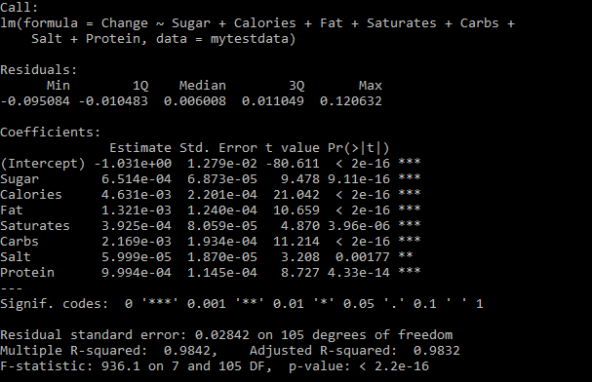

***Figure 34****: Results from Machine Learning Regression Analysis*

***7.2.2 Adding the Equation to the App***

The equation found was then added to the “Risk Foods” section of the app. Here, the user is also able to see the amount of each food group they require given their weight, height, age and gender, as well as compute the number of calories required to gain / lose a pound based on the St. Mifflin-Jeor equation.

The machine learning functionality is shown in figure 35. It takes the percentage contribution of that person’s daily intake and then determines the weight gain using the equation derived from the linear regression model.

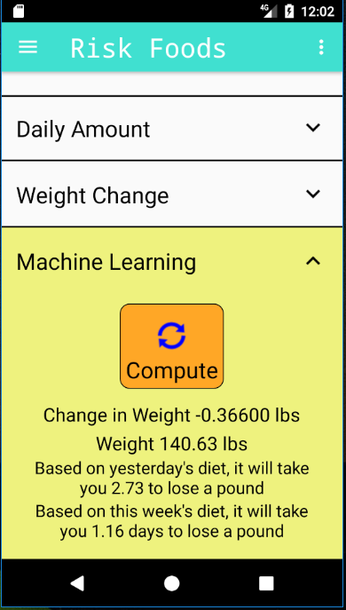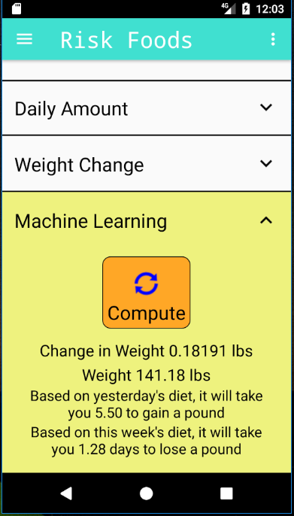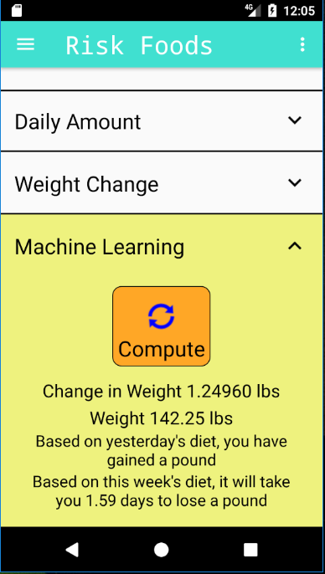

***Figure 35****: Machine Learning Functionality in the App*

Once the percentage contribution is calculated, the app looks at the user’s diet from the previous day and determines their weight change. If they’re change in weight is greater than 1, the app will tell them they have gained / lost a pound. Otherwise, it will inform them how many days it will take them, given yesterday’s diet, to gain / lose a pound. Moreover, the regression equation is used for a week of dieting data to determine, based on this week’s data, how long it will take the user to gain / lose weight. This is calculated by looking at the last 7 days (not including the current day) and determining the weight change using the regression equation. If the user does not have a full week’s data, they will be prompted with a message saying they need to log at least 7 days’ worth of food to use this feature.

***7.3 Evaluation of Machine Learning Results***

To evaluate this equation, a study on weight change given diet needs to be conducted. It is most likely unethical to ask students to give their weight over long periods, particularly if, on occasion, they are required to eat more to see if the classifier does in fact predict their weight gain. Therefore, this researcher monitored his own weight over a 2-week period and determined the level of accuracy of the classifier for each day, concluding whether its predictions are precise or not.

The researcher’s weight was measured each day for a period of 2 weeks, using the same set of scales at the same time of day. The rationale behind this approach was to compare the difference in the weight given by the equation and the actual weight of the researcher. The results of the study are highlighted in table 8.

**Table 8**: Machine Learning Evaluation

|  |  |  |  |  |  |  |
| --- | --- | --- | --- | --- | --- | --- |
| **Date** | **Time** | **Weight** | **Change** | **Predicted** | **Difference** | **Sig.** |
| 24/07/2017 | 10:00 | 134.1 | 0.14835 | 134.2484 | 0.04835 | 0.04 |
| 25/07/2017 | 10:38 | 134.2 | 0.72819 | 134.9282 | -1.07181 | 0.79 |
| 26/07/2017 | 10:32 | 136 | -0.59267 | 135.4073 | 0.00733 | 0.01 |
| 27/07/2017 | 10:30 | 135.4 | -0.28816 | 135.1118 | -0.08816 | 0.07 |
| 28/07/2017 | 10:29 | 135.2 | -0.54435 | 134.6557 | 0.05565 | 0.04 |
| 29/07/2017 | 10:30 | 134.6 | -0.61246 | 133.9875 | -0.01246 | 0.01 |
| 30/07/2017 | 10:30 | 134 | -0.14443 | 133.8556 | 0.05557 | 0.04 |
| 31/07/2017 | 10:47 | 133.8 | 0.21166 | 134.0117 | -0.18834 | 0.14 |
| 01/08/2017 | 10:21 | 134.2 | 0.20733 | 134.4073 | 0.00733 | 0.01 |
| 02/08/2017 | 10:30 | 134.4 | -0.01291 | 134.3871 | -0.11291 | 0.08 |
| 03/08/2017 | 10:28 | 134.5 | 0.77119 | 135.2712 | -0.02881 | 0.02 |
| 04/08/2017 | 10:34 | 135.3 | -0.58241 | 134.7176 | -0.08241 | 0.06 |
| 05/08/2017 | 10:20 | 134.8 | -0.20356 | 134.5964 | -0.00356 | 0.00 |
| 06/08/2017 | 10:30 | 134.6 | 0.57119 | 135.1712 | -0.02881 | 0.02 |
| 07/08/2017 | 10:31 | 135.2 | NA | NA | NA | NA |

During this process, the St. Mifflin-Jeor equation was also evaluated. The equation exists within the app under the “Weight Change” section of the Risk Foods activity. The purpose of doing this was to see the difference between the two equations and thereby determine the accuracy of the regression equation developed in this study. The results of the St. Mifflin-Jeor equation are seen in table 9.

Looking at the results of the evaluation, one could infer that the regression equation developed from this study gives a more accurate reading of someone’s change in weight than the St. Mifflin-Jeor equation. Considerably, 9 out of the 14 days showed a percentage change that was within a 5% confidence interval, opposed to just 2 out of 14 for the St. Mifflin-Jeor equation. Furthermore, 11 out of the 14 days, the regression equation predicted the change in weight to within 0.1 pound – opposed to just 4. Therefore, one could conclude that the regression equation is a reliable predictor of change in weight.

**Table 9**: St. Mifflin-Jeor Evaluation

|  |  |  |  |  |  |  |
| --- | --- | --- | --- | --- | --- | --- |
| **Date** | **Time** | **Weight** | **Change** | **Predicted** | **Difference** | **Sig.** |
| 24/07/2017 | 10:00 | 134.1 | 0.0553 | 134.1553 | -0.0447 | 0.03 |
| 25/07/2017 | 10:38 | 134.2 | 0.3076 | 134.5076 | -1.4924 | 1.10 |
| 26/07/2017 | 10:32 | 136 | -0.45684 | 135.5432 | 0.14316 | 0.11 |
| 27/07/2017 | 10:30 | 135.4 | -0.16991 | 135.2301 | 0.03009 | 0.02 |
| 28/07/2017 | 10:29 | 135.2 | -0.4454 | 134.7546 | 0.1546 | 0.11 |
| 29/07/2017 | 10:30 | 134.6 | -0.48861 | 134.1114 | 0.11139 | 0.08 |
| 30/07/2017 | 10:30 | 134 | 0.0315 | 134.0315 | 0.2315 | 0.17 |
| 31/07/2017 | 10:47 | 133.8 | 0.1066 | 133.9066 | -0.2934 | 0.22 |
| 01/08/2017 | 10:21 | 134.2 | 0.1124 | 134.3124 | -0.0876 | 0.07 |
| 02/08/2017 | 10:30 | 134.4 | -0.0156 | 134.3844 | -0.1156 | 0.09 |
| 03/08/2017 | 10:28 | 134.5 | 0.66656 | 135.1666 | -0.13344 | 0.10 |
| 04/08/2017 | 10:34 | 135.3 | -0.36789 | 134.9321 | 0.13211 | 0.10 |
| 05/08/2017 | 10:20 | 134.8 | -0.1041 | 134.6959 | 0.0959 | 0.07 |
| 06/08/2017 | 10:30 | 134.6 | 0.2716 | 134.8716 | -0.3284 | 0.24 |
| 07/08/2017 | 10:31 | 135.2 | NA | NA | NA | NA |

However, there are several factors that the regression equation hasn’t taken into consideration, such as metabolism and exercise – both of which would have a significant effect on someone’s change in weight given a particular diet. Therefore, one could infer that these results show significance in the prediction of the regression equation, but the accuracy is not absolute.

Furthermore, the conditions in which the results were obtained may not have been entirely accurate. The weighing scales used were accurate to the nearest 0.01 pound, whereas the regression equation predicted within 0.00001 pounds. Moreover, the times in which the researcher’s weight was calculated will depend considerably on the time since they had last eaten, amongst other things. Despite all the measurements having been taken within a one hour interval, this may not be entirely accurate as a person’s weight varies considerably throughout the day. One such way to improve this would have been to measure weight at 2 different times per day, and also ensure that other factors, such as: hours of rest; time of day weight measured; time food was consumed; etc., are the same for each day of the study.

8. Bibliography

Ahmad, N., Boota, M.W., and Masoom, A.H. (2014) Smart Phone Application Evaluation with Usability Testing Approach. *Journal of Software Engineering and Applications.* 7(1) pp. 1045-1054.

Alavifar, A., Karimimalayer, M., and Anuar, M.K. (2012) Structural equation modelling vs multiple regression: the first and second generation of multivariate techniques. *Engineering Science and Technology: An International Journal*. 2(2), pp. 326-329.

Al-Fedaghi, S. (2011) Developing Web Applications. *International Journal of Software Engineering and its Applications*. 5(2) pp. 57-68.

Android (2017a) *Android Activity Lifecycle* [Internet]. Available from:

https://developer.android.com/reference/android/app/Activity.html [Last accessed 31st January 2017].

Android (2017b) *Building Your First App* [Internet]. Available from: https://developer.android.com/training/basics/firstapp/index.html [Last accessed 19th January 2017].

Android (2017c). Transmitting Network Data Using Volley [Internet]. Available from https://developer.android.com/training/volley/index.html [Accessed 30th June 2017].

Android (2017d) *Adding Voice Capabilities* [Internet]. Available from https://developer.android.com/training/wearables/apps/voice.html [Accessed 25th July 2017].

Apache (2017) XAMPP Apache + MariaDB + PHP + Perl [Internet]. Available from https://www.apachefriends.org/index.html [Accessed 30th June 2017].

Arnhold, M., Quade, M., and Kirch, W. (2014) Mobile Applications for Diabetics: A Systematic Review and Expert-Based Usability Evaluation Considering the Special Requirements of Diabetes Patients Aged 50 Years or Older. *Journal of Medical Internet Research.* 16(4).

Balkar, K. (2013) Tutorial #28: Implement SHA1 and MD5 hashing in Android [Internet]. Available from https://karanbalkar.com/2013/05/tutorial-28-implement-sha1-and-md5-hashing-in-android/ [Accessed 30th June 2017].

Baresi, L., and Pezze, M. (2006) An Introduction to Software Testing. Electronic Notes in Theoretical Computer Science. 148(1), pp. 89-111.

Bhatti, T. (2007) Exploring Factors Influencing the Adoption of Mobile Commerce. *Journal of Internet Banking and Commerce*. 12 (3), pp. 1-13.

Bhosale, S.T., Patil, T., and Patil, P. (2015) SQLite: Light Database System. International Journal of Computer Science and Mobile Computing. 4(4), pp. 882-885.

Blundell, J.E., Caudwell, P., and Finlayson, G. (2012) Role of resting metabolic rate and energy expenditure in hunger and appetite control: a new formulation. *Disease Models and Mechanisms*. 5(5), pp. 608-661.

Borreli, L. (2014) *Food Insecurity: Why 59% of College Students May Suffer from Malnutrition* [Internet]. Available from: http://www.medicaldaily.com/food-insecurity-why-59-college-students-may-suffer-malnutrition-268109 [Last accessed 19th January 2017].

Boseley, S. (2015) *Poor diet 'biggest contributor to early deaths across the world'* [Internet]. Available from: https://www.theguardian.com/society/2015/sep/11/poor-diet-biggest-contributor-early-deaths-world-study [Accessed 13th February 2017].

Bray, G.A., and Popkin, B.M. (2014) Dietary Sugar and Body Weight: Have We Reached a Crisis in the Epidemic of Obesity and Diabetes? *American Diabetes Association*. 37(4), pp. 950-956.

Brown, D. M. (2011) *Communicating Design: Developing Web Site Documentation for Design and Planning* (2nd ed). New Riders Press, Berkeley, California.

Brown, J. (2014) How Connectivity Motivates Behaviour Change: Gamification as an Effective Social Media Platform for BC QuitNow Services. Professional Communication Thesis.

Buckley, P. and Doyle, E. (2016) Gamification and Student Motivation. *Interactive Learning Environment*. 24(6), pp. 1162-1175.

Burke, L.E., Wang, J., and Sevick, M.A. (2011) Self-Monitoring in Weight Loss: A Systematic Review of the Literature. *Journal of the American Dietetic Association*. 111(1), pp. 92-102.

Calculator.net (2017) Calorie Calculator [Internet]. Available from: http://www.calculator.net/calorie-calculator.html [Accessed 29th March 2017].

Cecchini, M., Sassi, F., Lauer, J.A., Lee, Y.Y., Guajardo-Barron, V., and Chisholm, D. (2010) Tackling of unhealthy diets, physical inactivity, and obesity: health effects and cost-effectiveness. *Lancet*. 376(1) pp. 1775-1784.

Chan, R.S.M., and Woo, J. (2010) Prevention of Overweight and Obesity: How Effective is the Current Public Health Approach. *International Journal of Environmental Research and Public Health*. 7(3), pp.765-783.

Chaplot, V. (2016) Cache Memory: An Analysis on Performance Issues. International Journal of Advance Research in Computer Science and Management Studies. 4(7), pp. 26-28.

Cisco. (2016). Global Mobile Data Traffic Forecast Update, 2015–2020 White Paper [Internet]. Available from: http://www.cisco.com/c/en/us/solutions/collateral/service-provider/visual-networking-index-vni/mobile-white-paper-c11-520862.html. [Accessed 6th March 2017].

Cook, J. (2016) *The Challenge of Gamification: Advice on How To Quickly Create Engaging Learning* [Internet]. Available from: https://www.trainingjournal.com/articles/news/challenge-gamification-advice-how-quickly-create-engaging-learning [Last accessed 19th January 2017].

Cugelman, B. (2013) Gamification: What It Is and Why It Matters to Digital Health Behaviour Change Developers. *Journal of Medical Internet Research Serious Games*. 1(1).

Davis, F.D., Bagozzi, R.P., and Warshaw, P.R. (1989) User Acceptance of Computer Technology: A comparison of two theoretical models. *Management Science*. 35(8), pp. 982-1003.

Deitterich, T.G. (1998) Machine Learning – Special issue on applications of machine learning and the knowledge discovery process. *Journal of Machine Learning*. 30(2), pp. 1-12.

Deliens, T., Clarys, P., Bourdeuadhuij, I.D., and Deforche, B. (2014) Determinants of eating behaviour in university students: a qualitative study using focus group discussions. *BMC Public Health*. 14(53), pp. 1-12.

Deshpande, S., Basil, M.D., and Basil. D.Z. (2009) Factors Influencing Healthy Eating Habits Among College Students: An Application of the Health Belief Model. *Health Marketing Quarterly*. 26(2), pp.145-164.

Dixon, A. (2008) Motivation and Confidence: What Does It Take To Change Behaviour? *The King’s Fund*.

Domingos, P. (2012) A few useful things to know about machine learning*. Communications of ACM*. 55(10), pp. 1-9.

Edwards, E.A., Lumsden, J., Rivas, C., Steed, L., Edwards, L.A., Thiyagarajan, A., Sohanpal, R., Caton, H., Griffiths, C.J., Munafo, M.R., Taylor, S., Walton, R.T. (2016) Gamification for health promotion: systematic review of behaviour change techniques in smartphone apps. *BMJ Open.* 2016(6), pp. 1-9.

Eisingerich, A.B. and Bell, S.J. (2008) *Customer Education Increases Trust* [Internet]. Available from http://sloanreview.mit.edu/article/customer-education-increases-trust/ [Accessed 6th March 2017].

Ferretti, F. (2015) Unhealthy Behaviours: An International Comparison. *Public Library of Science: PLOS ONE*. 10(10), pp. 1- 15.

Field, A. (2009) Discovering Statistics Using SPSS. 3rd ed. Sage, London.

Fielding, A. (2007) *Cluster and Classification Techniques for the Biosciences*. Cambridge University Press, Cambridge.

Food and Drink Federation (2017) *Reference Intakes (previously Guideline Daily Amounts)* [Internet]. Available from: http://www.foodlabel.org.uk/label/reference-intakes.aspx [Accessed 27th March 2017].

Frankenfield, D., Roth-Yousey, L., and Compher, C. (2005) Comparison of predictive equations for resting metabolic rate in healthy nonobsese and obese adults: a systematic review. *Journal of the America Diet Association*. 105(5), pp. 775-89.

Ganasegeran, K., Al-Dubai, S.R., Quershi, A.M., Al-abed, A.A., Rizal, A.M., and Aljunid, S.M. (2012) Social and Psychological Factors Affecting Eating Habits Among University Students in a Malaysian Medical School: A Cross-Sectional Study. *Nutritional Journal*. 11(48), pp. 1-7.

Garrett, J.J. (2010) *The Elements of User Experience: User-Centered Design for the Web and Beyond* (2nd ed). New Riders Press, Berkeley, California.

Granado-Font, E., Flores-Mateo, G., Sorli-Aguilar, M., Montana-Carreras, X., Ferre-Grau, C., Barrera-Uriarte, M.L., Oriol-Colominas, E., Rey-Renones, C., Caules, I., and Satue-Gracia, E.M. (2015) Effectiveness of a Smartphone Application and Wearable Device for Weight Loss In Overweight or Obese Primary Care Patients: Protocol for a Randomised Controlled Trial. *BMC Public Health*. 15(531), pp. 1-6.

Grave, R.D., Centis, E., Marzocchi, R., El Ghoch, M., and Marchesini, G. (2013) Major Factors for Facilitating Change in Behavioural Strategies to Reduce Obesity. *Psychology Research and Behaviour Management*. 6(1), pp. 101-110.

Griskevicious, V., and Kenrick, D.T. (2013) Fundamental motivs: How evolutionary needs influence consumer behaviour. *Journal of Consumer Psychology*. 23(3), pp. 372-286.

Hair, J.F., Black, W.C., Babin, B.J., and Anderson, R.E. (2014) *Multivariate Data Analysis*. 7th ed. Essex, Pearson Education Limited.

Hamari, J., Koivisto, J., and Sarsa, H. (2014) Does Gamification Work? – A Literature Review of Empirical Studies on Gamification. *47th Hawaii International Conference on System Science*. pp. 3025-3034.

Hasan, B. (2015) Perceived irritation in online shopping: The impact of website design characteristics. *Computers in Human Behaviour*. 54(1), pp.224-230.

[Høgenhaug](https://www.smashingmagazine.com/author/peter-steen-hogenhaug/), P.S. (2012) *Gamification and UX: Where Users Win or Lose* [Internet]. Available from https://www.smashingmagazine.com/2012/04/gamification-ux-users-win-lose/ [Accessed 4th March 2017].

Holla, S. and Katti, M.M. (2012) Android Based Mobile Application Development and its Security. *International Journal of Computer Trends and Technology*. 3(3) pp. 486-490.

Holst, E., and Thyregod, P. (1999) A statistical test for the mean squared error. *Journal of Statistical Computation and Simulation*. 63(4), pp. 321-347.

Howlett, N., Trivedi, D., Troop, N.A., and Chater, A.M. (2015) What are the most effective behaviour change techniques to promote physical activity and/or reduce sedentary behaviour in inactive adults? A systematic review protocol. *BMJ Open*. 5(8) pp. 1-6.

Jahado, P. (2017) *MPAndroidChart* [Internet]. Available from https://github.com/PhilJay/MPAndroidChart [Accessed 25th July 2017].

Khaleghi, A., Ryabko, D., Mary, J., and Preux, P. (2016) Consistent Algorithms for Clustering Time Series. *Journal of Machine Learning Research*. 17(1), pp. 1-32.

Kinard, B.R., and Webster, C. (2011) Factors Influencing Unhealthy Eating Behaviour in US Adolescents. *International Journal of Consumer Studies*. 36(1), pp. 23-29.

King, D., Greaves, F., Exeter, C., Darzi, A. (2013) ‘Gamification’: Influencing Health Behaviours with Games. *J R Soc Med*. 106(1) pp. 76-78.

Landers, R.N. (2014) Developing a Theory of Gamified Learning: Linking Serious Games and Gamification of Learning. *Simulation & Gaming*. 45(6) pp. 752-768.

Lawanna, A. (2012) The Theory of Software Testing. Department of Information Technology, Faculty of Science and Technology

Leung, H.K., and Wong, P.W. (1997) A study of user acceptance tests. Software Quality Journal. 6(2), pp. 137-149.

Lima, A.C.S., Araujo, M.F.M., Freier de Freitas, R.W.J., Zanetti, M.L., Cesar de Almeida, P., and Damasceno, M.M.C. (2014) Risk Factors for Type 2 Diabetes Mellitus in College Students: Association with Sociodemographic variables. *Revista Latino-Americana de Enfermagem*. 22(3), pp. 484-490.

Lippevelde, W.V., Vangeel, J., De Cock, N., Lachat, C., Goossens, L., Beullens, K., Vervoort, L., Braet, C., Maes, L., Eggermont, S., Deforche, B., and Van Camp, J. (2016) Using a gamified monitoring app to change adolescent’s snack intake: the development of the reward app and evaluation design. *BMC Public Health.* 16(725), pp.1-11.

Lazaric, A., Ghavamzadeh, M., and Munos, R. (2016) Analysis of Classification-based Policy Iteration Algorithms. *Journal of Machine Learning Research*. 17(1), pp.1-30.

Lee, Y., and Kozar, K.A. (2012) Understanding of website usability: specifying and measuring constructs and their relationships. *Decision Support Systems*. 52(1), pp. 450-463.

Lister, C., West, J.H., Cannon, B., Sax, T., and Brodegard, D. (2014) Just a Fad? Gamification in Health and Fitness Apps. *Journal of Medical Internet Research Serious Games*. 2(2), pp. 1-12.

Locke, E.A. and Latham, G.P. (2002) Building a practically useful theory of goal setting and task motivation. *American Psychologist*. 57(9), pp. 705-717.

Lunenburg, F.C. (2011) Goal-Setting Theory of Motivation. *International Journal of Management, Business, and Administration*. 15(1), pp. 1-6.

Ma, L. Gu, L. and Wang. J. (2014). Research and Development of Mobile Application for Android Platform. *International Journal of Multimedia and Ubiquitous Engineering*. 9(4) pp. 187-198.

Maetschke, S.R., Madhamshettiwar, P.B., Davis, M.J., and Ragan, M.A. (2014) Supervised, semi-supervised and unsupervised inference of gene regulatory networks. *Briefings in Bioinformatics*. 15(2), pp. 195-211.

Malhotra, N.K., and Birks, D.F. (2006) *Marketing Research: An Applied Approach*. 2nd ed. Pearson Education Limited, Essex.

Mathworks (2017) *Unsupervised* *Learning* [Internet]. Available from: https://uk.mathworks.com/discovery/unsupervised-learning.html [Accessed 15th March 2017].

McNeill, P., and Chapman, S. (2005) *Research Methods*. 3rd ed. Routledge, New York.

Mellouk, A., and Chebira, A. (2009) *Machine Learning*. InTech, ISBN 978-3-902613-56-1.

Middelweerd, A., Mollee, J.S., van der Wal, C.N., Burg, J., and te Velde, S.J. (2014) Apps to Promote Physical Activity Among Adults: A Review and Content Analysis*. International Journal of Behavioural Nutrition and Physical Activity*. 11(97), pp. 1-9.

Mifflin, M.D., St Jeor, S.T., Hill, L.A., Scott, B.J., Daugherty, S.A., and Koh, Y.O. (1990) A new predictive equation for resting energy expenditure in healthy individuals. *The American Society for Clinical Nutrition*. 51(2), pp. 241 – 247.

Moreira, P.I. (2013) High-sugar diets, type 2 diabetes, and Alzheimer’s disease. *PubMed: Current Opinion in Clinical Nutrition and Metabolic Care*. 16(4) pp. 440-445.

Nielsen, J. (2012) *Usability 101: Introduction to Usability* [Internet]. Available from https://www.nngroup.com/articles/usability-101-introduction-to-usability/ [Accessed 4th March 2017].

Nutritionix (2017) Nutritionix [Internet]. Available from https://www.nutritionix.com/ [Accessed 30th June 2017].

Osamor, V.C., Adebiyi, E.F., Oyelade, J.O., and Doumbia, S. (2012) Reducing the Time Requirement of k-Means Algorithm. *Public Library of Science*. 7(12), pp. 1-26.

Park. H. J., and Bae, J.H. (2014) Study and Research of Gamification Design. *International Journal of Software Engineering and Its Applications*. 8(8) pp. 19-28.

Patton-Lopez, M.M., Lopez-Cevallos, D.F., Cancel-Tirado, D.I., and Vasquez, L. (2014) Prevalence and Correlates of Food Insecurity Among Students Attending a Midsize Rural University in Oregon. *Journal of Nutrition Education and Behaviour.* 46(3), pp.209-14.

Rakestraw, T.L., Eunni, R.V., and Kasuganti, R.R. (2012) The Mobile Apps Industry: A Case Study. *Journal of Business Cases and Applications*. 9(1) pp. 1-26.

Rao, V. (2012) *Freshdesk Launches Help Desk Gamification Platform, Freshdesk Arcade* [Internet]. Available from https://yourstory.com/2012/09/freshdesk-launches-help-desk-gamification-platform-freshdesk-arcade/ [Accessed 6th March 2017].

Robertson, M. (2010) *Can’t Play, Won’t Play [*Internet]. Available from http://kotaku.com/5686393/cant-play-wont-play [Accessed 6th March 2017].

Rhee, K.S. and Sigler, T.H. (2005) Science Versus Humankind: The Yin and Yang of Motivation Theory. *International Journal of Organisation Theory and Behaviour*. 8(3), pp. 313-342.

Richardson, A.S., Arsenault, J.E., Cates, S.C., and Muth, M.K. (2015) Perceived Stress, unhealthy eating behaviours, and severe obesity in low-income women. *Nutritional Journal*. 14(122), pp. 1-10.

Ryan, R.M. and Deci, E.L. (2000) Self-Determination Theory and the Facilitation of Intrinsic Motivation, Social Development, and Well-Being. *American Psychology Association*. 55(1), pp. 68-78.

Scandit (2017) *Integrate the Scandit Barcode Scanner SDK into your app* [Internet]. Available from http://docs.scandit.com/5.1/android/android-integrate.html [Accessed 25th July 2017].

Sherwani, Y., Ahmed, M., Muntasir, M., El-Hilly, A., Iqbal, S., Siddiqui, S., Al-Fagih, Z., Usmani, O., and Eisingerich, A.B. (2015) Examining the role of gamification and use of mHealth apps in the context of smoking cessation: a review of extant knowledge and outlook. Imperial College, London, pp. 1- 44.

Shelemy, L. (2017) *Behaviour Change Techniques in Smartphone Health Apps* [Internet]. Available from: http://www.nationalelfservice.net/treatment/self-management-treatment-and-prevention/behaviour-change-techniques-smartphone-health-apps/. [Accessed 19th January 2017].

Shilts, M.K., Horowitz, M., and Townsend, M.S. (2004) Goal Setting as a Strategy for Dietary and Physical Activity Behaviour Change: A Review of the Literature. *The Science of Health Promotion*. 19(2), pp. 81-93.

Skogberg, B. (2010) Android Application Development – A Guide for the Intermediate Developer. Computer Science Thesis. Malmo University.

Styles, S. (2017) *50-30-20 Diet Plans* [Internet]. Available from http://www.livestrong.com/article/317610-50-20-30-diet-plans/ [Accessed 25th July 2017].

Taitano, M.C., and Smith, V. (2015) Eating Habits in College [Internet]. Available from: https://rampages.us/healthuniv200/2016/10/12/eating-habits-in-college/ [Accessed 19th January 2017].

Tanton, J., Dodd, L.J., Woodfield, L., and Mabhala, M. (2015) Eating Behaviours of British University Students: A Cluster Analysis on a Neglected Issue. Hi*ndawi Publishing Corporation, Advances in Preventive Medicine*. 2015, pp.1-8.

Thompson, S.K. (2012) *Sampling*. 2nd ed. Wiley Series in Probability and Statistics, Canada.

Tutorials Point (2017) System Testing [Internet]. Available from https://www.tutorialspoint.com/software_testing_dictionary/system_testing.htm [Accessed 30th June 2017].

Usability.gov (2013) Wireframing [Internet]. Available from: https://www.usability.gov/how-to-and-tools/methods/wireframing.html [Accessed 4th March 2017].

Uyanik, G.K., and Guler, N. (2013) A study on multiple linear regression analysis. *Procedia – Social and Behavioural Sciences.* 106(1), pp. 234-240.

Varian, H.R. (2014) Big Data: New Tricks for Econometrics. *Journal of Economic Perspectives*. 28(2), pp. 3-28.

Walz, A. (2016) Gamification: The Science and Software to Make You More Productive [Internet]. Available from https://zapier.com/blog/gamification-apps/ [Accessed 6th March 2017].

Wilson, G.T., Bhamra, T., and Lilley, D. (2015) The Considerations and Limitations of Feedback as a Strategy for Behaviour Change. *International Journal of Sustainable Engineering*. 8(3), pp. 185-196.

Wodtke, C., and Govella, A. (2009*) Information Architecture: Blueprints for the Web.* (2nd ed). New Riders Press, Berkeley, California.

Yanez, C. (2014) Create a Basketball Free Throw Game with Unity [Internet]. Available from: https://code.tutsplus.com/tutorials/create-a-basketball-free-throw-game-with-unity--cms-21203 [Accessed 5th March 2017].

Young, S. (2014) Healthy Behaviour Change in Practical Settings. *The Permanente Journal*. 18(4), pp. 89-92.

Zhao, J., Freeman, B., and Li, M. (2016) Can Mobile Phone Apps Influence People’s Health Behaviour Change? An Evidence Review. *Journal of Medical Internet Research*. 18(11), pp. 1-12.

Zhu, F., Bosch, M., Woo, I., Kim, S.Y., Boushey, C.J., Ebert, D.S., and Delp, E.J. (2010) The Use of Mobile Devices in Aiding Dietary Assessment and Evaluation. *IEEE Journal of Selected Topics in Signal Processing*. 4(4), pp. 756-766.

**App Images**

Congerdesign (2017) Raspberries [digital image]. Available from https://pixabay.com/en/raspberries-berries-fruits-fruit-2431029/ [Accessed 25th July 2017].

Jill111 (2017) *Cherries* [digital image]. Available from https://pixabay.com/en/cherries-bowl-pink-fruit-breakfast-2402449/ [Accessed 25th July 2017].

Jony (2017) *Book* [digital image]. Available from https://thenounproject.com/search/?q=diary&i=879647 [Accessed 25th July 2017].

Kovyazin, A. (2017) *Sugar Cubes* [digital image]. Available from https://thenounproject.com/search/?q=sugar%20cube&i=579820 [Accessed 25th July 2017].

Pezibear (2017) *Strawberry* [digital image]. Available from https://pixabay.com/en/strawberries-red-frisch-ripe-1398159/ [Accessed 25th July 2017].

Soorelis (2017) *Sugar* [digital image]. Available from https://pixabay.com/en/eat-sugar-calories-food-sweet-567451/ [Accessed 25th July 2017].

9. APPENDICES

**Appendix A:** Images

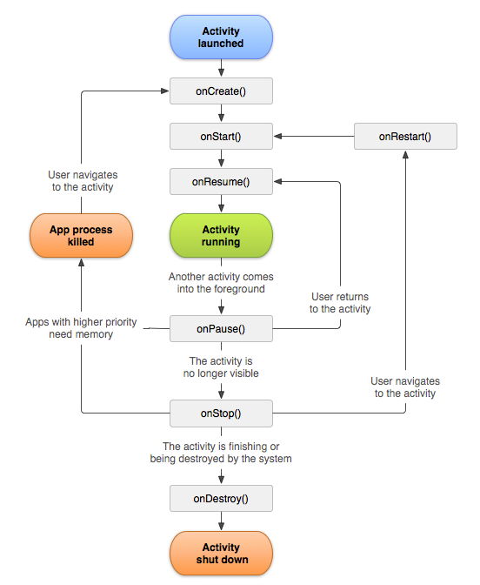

***Fig. 36****: Android Activity Lifecycle (Android, 2017b)*

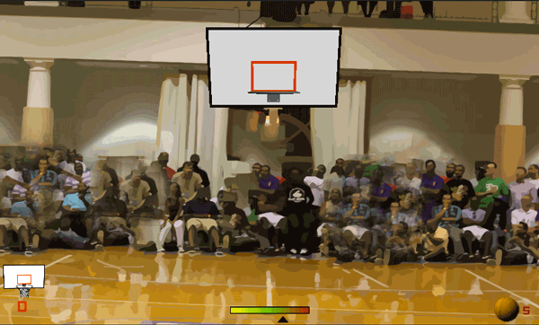

***Fig. 37:*** *Basketball Free-Throw Game – Design (Yanez, 2014)*

**Appendix B:** Wireframes

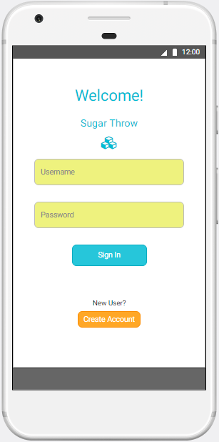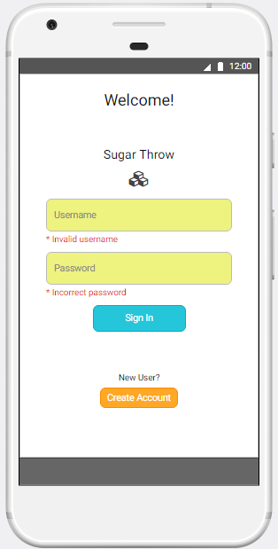

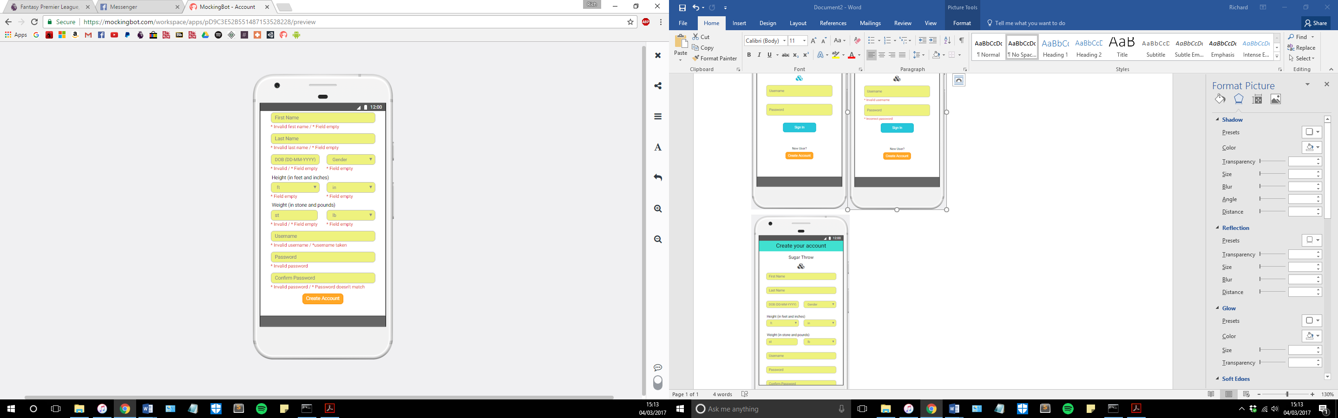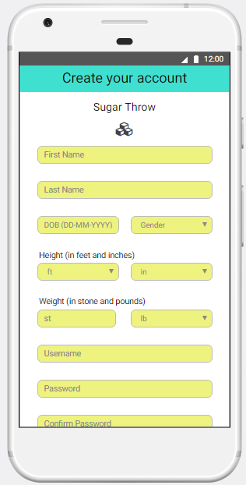

***Fig. 38:*** *Wireframes for Creating an account*

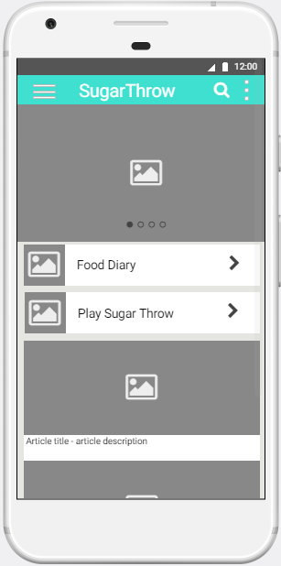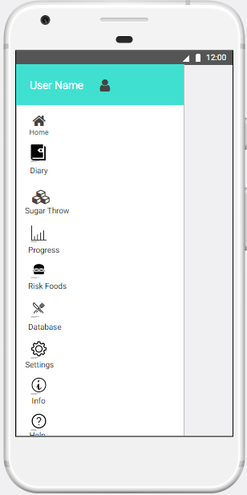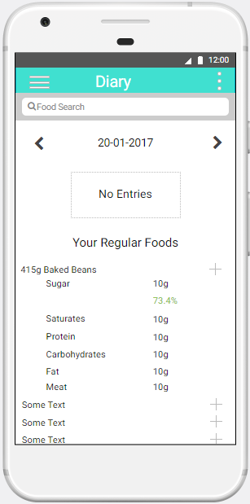

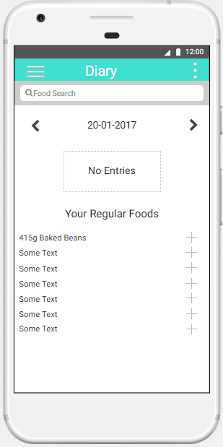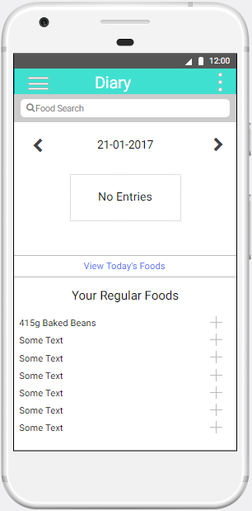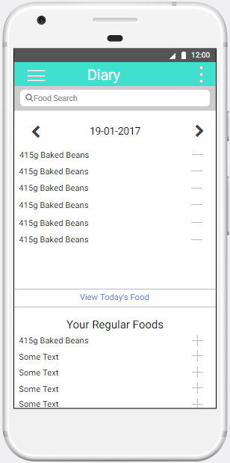

***Fig. 39:*** *Wireframes from the App*

**Appendix C:** Database Schema

This section highlights the database schema. For the app’s internal database (which will utilise information from the Nutritionix API) there will 3 tables. These are: ‘User’, ‘Food’, and ‘Diary’.

‘User’ and ‘Diary’ have a one-to-one relationship, as a user can only have access to one diary and that diary is only accessed by one user. ‘Diary’ and ‘Food’ have a many-to-many relationship, as a ‘Diary’ can have many foods in it, and ‘Food’ can be in many different diaries.

Below is a UML Entity Relationship diagram, using Crow’s foot notation to show the relationships.

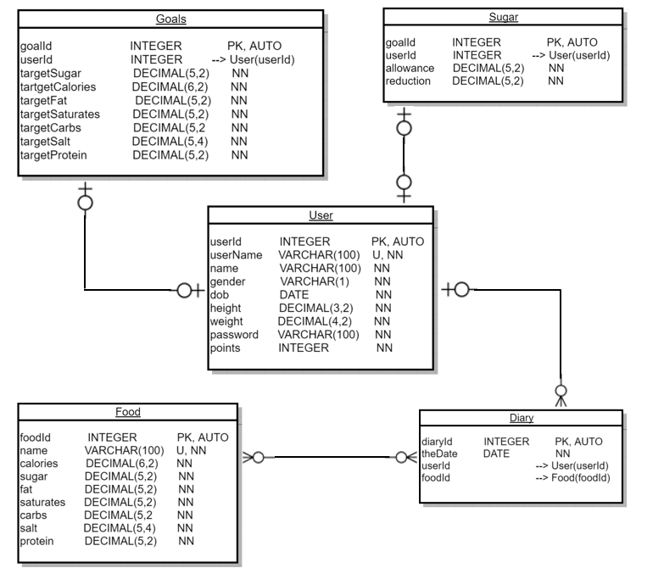

***Fig. 40****: Schema for Database. U = Unique, NN = Not NULL*

***Fig. 41:*** *Create / Drop Script for Local SQLite**Database*

**DROP TABLE** IF **EXISTS** Sugar;   
**DROP TABLE** IF **EXISTS** Goals;   
**DROP TABLE** IF **EXISTS** Diary;   
**DROP TABLE** IF **EXISTS** Food;   
**DROP TABLE** IF **EXISTS User**;   
  
**CREATE TABLE User** (  
 userId **INTEGER NOT NULL PRIMARY KEY** AUTOINCREMENT,   
 userName **VARCHAR**(100) **NOT NULL**,   
 name **VARCHAR**(100) **NOT NULL**,   
 gender **VARCHAR**(1) **NOT NULL**,   
 dob **DATE NOT NULL**,   
 height **DECIMAL**(3, 2) **NOT NULL**,   
 weight **DECIMAL**(4, 2) **NOT NULL**,  
 password **VARCHAR**(100) **NOT NULL**,   
 points **INTEGER NOT NULL**,   
 **CONSTRAINT** userName_unique **UNIQUE** (userName)  
);  
  
**CREATE TABLE** Food (  
 foodId **INTEGER NOT NULL PRIMARY KEY** AUTOINCREMENT,   
 name **VARCHAR**(100) **NOT NULL**,  
 calories **DECIMAL**(5,2),   
 sugar **DECIMAL**(5, 2),  
 fat **DECIMAL**(5, 2),   
 saturates **DECIMAL**(5, 2),   
 carbs **DECIMAL**(5, 2),   
 salt **DECIMAL**(5, 4),   
 protein **DECIMAL**(5, 2),  
 **CONSTRAINT** name_unique **UNIQUE** (name)  
);  
  
**CREATE TABLE** Diary (  
 diaryId **INTEGER NOT NULL PRIMARY KEY** AUTOINCREMENT,   
 theDate **DATE NOT NULL**,   
 userId **INTEGER NOT NULL**,   
 foodId **INTEGER NOT NULL**,   
 **CONSTRAINT** fk_userId **FOREIGN KEY** (userId) **REFERENCES User**(userId),   
 **CONSTRAINT** fk_foodId **FOREIGN KEY** (foodId) **REFERENCES** Food(foodId)  
);   
  
**CREATE TABLE** Goals (  
 goalId **INTEGER NOT NULL PRIMARY KEY** AUTOINCREMENT,   
 userId **INTEGER NOT NULL**,  
 targetSugar **DECIMAL** (5, 2),   
 targetCalories **DECIMAL**(5, 2),   
 targetFat **DECIMAL**(5, 2),   
 targetSaturates **DECIMAL**(5, 2),   
 targetCarbs **DECIMAL**(5, 2),   
 targetSalt **DECIMAL**(5, 2),   
 targetProtein **DECIMAL**(5, 2),  
 **CONSTRAINT** unique_userId **UNIQUE** (userId),  
 **CONSTRAINT** fk_userId **FOREIGN KEY** (userId) **REFERENCES User**(userId)  
);  
  
  
**CREATE TABLE** Sugar (  
 goalId **INTEGER NOT NULL PRIMARY KEY** AUTOINCREMENT,   
 userId **INTEGER NOT NULL**,  
 allowance **DECIMAL**(5, 2),   
 reduction **DECIMAL**(5, 2),  
 **CONSTRAINT** unique_userId **UNIQUE** (userId),  
 **CONSTRAINT** fk_userId **FOREIGN KEY** (userId) **REFERENCES User**(userId)  
);

***Fig. 42:*** *Create / Drop Script for Online Database*

**DROP TABLE** IF **EXISTS** Contents;   
**DROP TABLE** IF **EXISTS** Users;   
  
**CREATE TABLE** Users (  
 userId **INTEGER NOT NULL PRIMARY KEY** AUTO_INCREMENT,   
 userName **VARCHAR**(100) **NOT NULL**,   
 name **VARCHAR**(100) **NOT NULL**,   
 gender **VARCHAR**(1) **NOT NULL**,   
 dob **DATE NOT NULL**,   
 height **DECIMAL**(3, 2) **NOT NULL**,   
 weight **DECIMAL**(4, 2) **NOT NULL**,  
 password **VARCHAR**(100) **NOT NULL**,   
 points **INTEGER NOT NULL**,   
 **CONSTRAINT** userName_unique **UNIQUE** (userName)  
);  
  
**CREATE TABLE** Contents(  
 contentId **INTEGER NOT NULL PRIMARY KEY** AUTO_INCREMENT,   
 userId **INTEGER NOT NULL**,   
 theDate **DATE NOT NULL**,   
 calories **DECIMAL**(6,2),   
 sugar **DECIMAL**(5, 2),  
 fat **DECIMAL**(5, 2),   
 saturates **DECIMAL**(5, 2),   
 carbs **DECIMAL**(5, 2),   
 salt **DECIMAL**(5, 4),   
 protein **DECIMAL**(5, 2)  
);

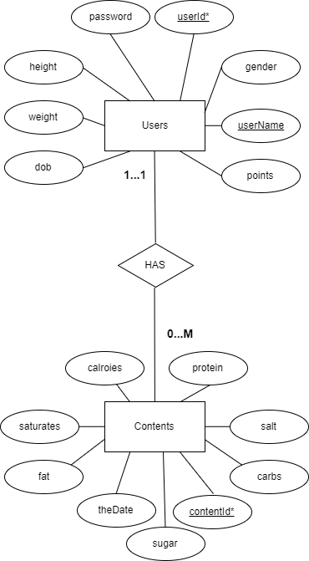

***Fig. 43:*** *E/R Diagram for Online Database*

**Appendix D:** Questionnaire

**Q1. What is your gender?**

|  |  |  |
| --- | --- | --- |
| Male | Female | Prefer Not to Say |

**Q2. How old are you? Please enter below**

|  |
| --- |
|  |

**Q3. What year of your degree are you in?**

|  |  |  |  |  |
| --- | --- | --- | --- | --- |
| First Year | Second Year | Final Year | Master’s Year | PhD |

**Q4. What course are you studying?**

|  |
| --- |
|  |

**Q5. The following statements refer to the goal-setting functionality of the app. If you were asked NOT to set goals, please skip and go to question 6.**

|  |  |  |  |  |  |
| --- | --- | --- | --- | --- | --- |
|  | *Strongly Disagree (1)* | *Disagree (2)* | *Neither Agree nor Disagree (3)* | *Agree (4)* | *Strongly Agree (5)* |
| The ability to set goals is very important to me | O | O | O | O | O |
| Setting goals for myself helped me to improve my eating habits | O | O | O | O | O |
| The ability to set goals was useful to me | O | O | O | O | O |
| The need to reach my goal made me want to use the app more often | O | O | O | O | O |

**Q6. The following statements refer to the feedback functionality of the app.**

|  |  |  |  |  |  |
| --- | --- | --- | --- | --- | --- |
|  | *Strongly Disagree (1)* | *Disagree (2)* | *Neither Agree nor Disagree (3)* | *Agree (4)* | *Strongly Agree (5)* |
| Personalised feedback is very important to me | O | O | O | O | O |
| The feedback I received from the app was useful to me | O | O | O | O | O |
| Feedback encouraged me to use the app more often | O | O | O | O | O |
| Feedback helped me to improve my eating habits | O | O | O | O | O |

**Q7. The following statements refer to the ability to self-monitor your own diet and how you felt about this.**

|  |  |  |  |  |  |
| --- | --- | --- | --- | --- | --- |
|  | *Strongly Disagree (1)* | *Disagree (2)* | *Neither Agree nor Disagree (3)* | *Agree (4)* | *Strongly Agree (5)* |
| The ability to monitor my own behaviour is important to me | O | O | O | O | O |
| I would prefer to monitor my own behaviour than to have someone monitor it for me | O | O | O | O | O |
| The app made it easy for me to monitor my own behaviour | O | O | O | O | O |
| Self-monitoring of my behaviour helped improve my eating habits | O | O | O | O | O |

**Q8. The following statements refer to the overall effectiveness of the app**

|  |  |  |  |  |  |
| --- | --- | --- | --- | --- | --- |
|  | *Strongly Disagree (1)* | *Disagree (2)* | *Neither Agree nor Disagree (3)* | *Agree (4)* | *Strongly Agree (5)* |
| The app encouraged me to eat healthy | O | O | O | O | O |
| The app made me monitor my sugar consumption more closely | O | O | O | O | O |
| Overall, this app was effective in improving my eating habits | O | O | O | O | O |

These questions are open-ended – allowing the respondents to give a more detailed account of their experiences with the app.

**Q9. What do you think worked well?**

|  |
| --- |
|  |

**Q10. What do you think could be improved?**

|  |
| --- |
|  |

**Q11. Did you experience any problems with the app?**

|  |
| --- |
|  |

**Appendix E:** Responses to Open-ended Questions in Questionnaire

**Table 10:** Questionnaire Question – What do you think worked well?

|  |  |
| --- | --- |
| **Student** | **Response** |
| *Student 1* | The pie charts and figures helped monitor consumption effectively and easily show issues in my diet |
| *Student 2* | “The ability to go back and add foods to previous days was great, especially when no access to wifi” |
| *Student 3* | “I liked that the content changed every day” |
| *Student 4* | “Didn't find any bugs, everything seemed to work fine” |
| *Student 5* | “Was easy for me to use, and I liked how you could add foods to previous days” |
| *Student 6* | “Just having to add the foods I was going to be eaten made me think about how unhealthy my diet was” |
| *Student 7* | “Felt it was quite easy to use once I'd gotten used to it” |
| *Student 8* | “Everything seemed to work fine” |
| *Student 9* | *DID NOT ANSWER* |
| *Student 10* | “The popups were really useful as it helped me realise when I was eating too much of a certain food. They stopped me eating certain foods on some days” |

**Table 11:** Questionnaire Question – What do you think could be improved?

|  |  |
| --- | --- |
| **Student** | **Response** |
| *Student 1* | “The database was not wide enough and did not include a place to add your own nutritional information” |
| *Student 2* | “I would have preferred a place to track my weight as well as intake of nutritional info” |
| *Student 3* | “The UI didn't look great, needed a more polished, professional look” |
| *Student 4* | “The popups appeared too regularly” |
| *Student 5* | “Perhaps make the app more colourful, might make it more appealing” |
| *Student 6* | “In diary, removing foods could have been done better, perhaps by swiping to remove” |
| *Student 7* | “Took a long time to enter all the ingredients for when I'd created my own meal. Would be good if there was a way to enter this meal into the app so I could just add it if I ate it again” |
| *Student 8* | “When you search, it would be good to display the items automatically without having to press the search button” |
| *Student 9* | “Some of the app's features weren't clear to me; had to ask how to use it” |
| *Student 10* | “A quicker way to see progress from other days” |

**Table 12:** Questionnaire Question – Did you experience any problems?

|  |  |
| --- | --- |
| **Student** | **Response** |
| *Student 1* | “I couldn't retrieve my password once I’d forgotten it – luckily managed to remember it” |
| *Student 2* | “No” |
| *Student 3* | “It was hard to find the foods I had eaten” |
| *Student 4* | “Took me a while to get used to the UI” |
| *Student 5* | “No” |
| *Student 6* | “None that I can think of” |
| *Student 7* | “No” |
| *Student 8* | “No app seemed to work fine” |
| *Student 9* | “The UI looks really basic and the homepage is rather ugly” |
| *Student 10* | “Switching to see the progress of a previous day took some time” |

**Table 13:** Questionnaire Question – Other Comments

|  |  |
| --- | --- |
| **Student** | **Response** |
| *Student 1* | “The home page was interesting and changed every day” |
| *Student 2* | DID NOT ANSWER |
| *Student 3* | “The functionality of the app worked fine, but the UI wasn't very attractive. A different colour scheme would have been better” |
| *Student 4* | “I did like how the homepage changed every day, it made me want to see what the newest tip of the day was” |
| *Student 5* | DID NOT ANSWER |
| *Student 6* | “The content which changed every day was useful, but would be good if it was completely different each week” |
| *Student 7 – 9* | DID NOT ANSWER |
| *Student 10* | “Everything seemed to work well bar a few features” |

1. SRA refers to secondary research aim (or sub-aim)